


Siraro CFDA

Communities Caring for Children Programme (CCCP)

CCCP Baseline Survey 2012

Ethiopia, country specific report

Based on data collected between Sept and Dec 2012 from:
Siraro District, Ethiopia

Final draft report March 2013

By: CRC,
Creative Research and Evaluation Centre, Uganda
and
Ethiopia in-country analysis team
Assefa Balcha , M&E Officer NO
Thomas Fedlu, CCCP Coordinator
Jarso Wakeyo, Oromia Area Coordinator
Yilma Tibeso, SCFDA Manager
Bedane Bentulu, CCCP ECD Officer
Abdurehman Weyesa, ECD & Health Officer
Tekalign Kelbesa, CCCP VSL Officer
Kiniso Deko, CCCP M&E Officer
Wasihun Mebrate, CCCP Finance Officer
Mulugeta Tefera, M&E Consultant

Table of Contents
Executive summary iv
Key findings iv
Conclusion vii
Recommendations and potential follow up actions vii
Acknowledgements ix
Acronyms/Abbreviations ix
1. Background and introduction 10
1.1 Background to early childhood development 10
1.2 Introduction to ChildFund ECD project in Ethiopia 11
1.3 Objectives of the baseline survey 12
1.4 Context: ECD in Ethiopia 12
2. Methodology of the baseline 13
2.1 Design, sampling, preparation, and data collection 13
2.2 Limitations and challenges of the baseline survey 14
2.3 Note to reader: How findings are presented 15
3. Settings and demographics 16
3.1 Context: Siraro Woreda/District [from literature] 16
3.2 Communities & infrastructure [from survey] 16
3.3 Household demographics 17
3.4 Household livelihoods 19
4. Household vulnerability 22
4.1 Economic poverty 22
4.2 Food security/insecurity 23
4.3 Water, sanitation and hygiene 23
4.4 Presence of vulnerable persons in households 27
4.5 Social group membership 28
4.6 Exposure to domestic violence 29
5. Children’s vulnerability 30
5.1 Children separated from biological parents 30
5.2 Child identity: Birth records & birth registration 30
5.3 Children with disability 31
5.4 Occurrence & management of child rights violations 32
5.5 Child disciplining: Disciplinary practices in households 33
6. Early childhood care & development 35
6.1 Prenatal care 35
6.2 Immunization status 35
6.3 Growth monitoring and feeding practices 36
6.4 Nutrition status of children under 3 years 38
6.5 Health - Childhood illness management 38
7. Home child care & early mental stimulation 42
7.1 Household interactions with children 0 to 6 years 42
7.2 Positive care giving: parental engagement & learning 43
7.3 Child care arrangements when caregiver is away 44
7.4 Attaining milestones - Attachment of infants to caregiver 46
7.5 Attaining milestones - Psycho-social development 46
7.6 Opportunities to improve parenting - parent education 47
8. Enrolment and attendance of ECD 49
8.1 ECD enrolment 49
8.2 ECD attendance for children 3 to 6 years 50
8.3 Children’s school readiness 52
8.4 Primary school enrolment 52
8.5 Primary school attendance 54
9. Access to ECD facilities and primary schools 54
9.1 Accessing ECD care and education facility 54
9.2 Costs of care and education for children in ECD facilities 56
9.3 Parent participation both ECD and Grade 1 56
10. ECD and education services 58
10.1 ECD in Siraro: status, facilities, availability & access 58
10.2 Linkages between ECD facilities and other structures 60
10.3 Physical environment of the ECD facility classrooms 61
10.4 Primary schools and their readiness for children 63
11. Children’s competency in counting, literacy and numeracy 65
Competency of children in ECD 65
Competency of children in grade 1 66
12. Conclusion and Recommendations 68
Conclusion 68
Recommendations and potential follow up actions 68
ANNEX 70
Annex 1: Baseline survey team 70
Annex 2: Baseline survey sampled visited 71
ANNEX 3: Technical notes on growth measurements 72
ANNEX 4: Technical note on significance of early child care and stimulation at home 73

Executive summary

Introduction
This baseline survey, a key M&E and learning event in the Communities Caring for Children Programme (CCCP), was designed to document the status of the programme indicators prior to starting interventions in the three programme countries – Ethiopia, Mozambique and Uganda. In Ethiopia, the survey was conducted as a participatory exercise that engaged ChildFund National office staff, CCCP staff and members of the implementation partner, Siraro Children and Family Development Association (SCFDA). This participation went all the way through from design to data collection and analysis.
Drawing on the programme’s M&E and Learning plan, the survey used quantitative and qualitative methods to assess the status of children 0 to 5 years, including the status and quality of early childhood care and development (ECCD) services in the programme areas. The survey collected data from five Kebeles in Siraro District (Alemtena Sirbo, Boye Awarkasa, Damine Leman, Ropi 01 and Ropi Sinta). The total data set was 100 households, 8 pre-schools (‘zero classes’), 2 ECD centres, 8 primary 1 classes and 5 kebele leaders. Among children, the survey assessed self-awareness, counting, numeracy and literacy competencies of children currently in ECD facilities (127) and grade 1 (103).
Siraro Woreda is a rural drought-prone, densely populated area located 325km from Addis Ababa in the West Arsi Zone of Oromia Regional State. Infrastructure, facilities and services in Siraro are generally limited and of low quality. The total district population is 196,964, of which 94% is rural. About one in six (16%) of the population is below 5 years and half (50%) are below 15 years.

Key findings

Household vulnerability
The majority (80%) of children under 5 years live in vulnerable households that are dependent on crop farming with non-literate head of household (70% illiterate) and primary caregivers (91% illiterate). The majority of households have a limited asset profile – 83% have no means of transport; 79% live in homes with temporary roofing materials (grass); and 44% have no livestock of their own. Most of households (91%) suffer food shortages over the course of a year, causing reductions in the amounts and/or frequency of feeding. Only 18% of households achieved the minimum food dietary diversity score for children under 3 years, i.e., food from four or more food groups in a 24 hour recall period.
While most households have access to safe water (80%), sanitation is generally inadequate and hygiene is poor. About two-thirds (69%) of households have latrines but only 2% have improved latrines; and only 1% have hand-washing facilities and supplies to use after defecation. Only 25% of primary caregivers reported washing with soap before eating and after defecation/or cleaning a child.

Children vulnerability
Children are exposed to violence either as violence between adults in the home, abuse of children within or outside households and as part of disciplinary measures. About one in 8 households (13%) mentioned at least one incident of domestic violence within a 12 month recall period. About two-thirds of households (63%) reported only non-violent means of disciplining children, but more than one-third (37%) reported the use of violent disciplinary measures (corporal punishment, hit with stick or some other hard thing, spank, slap child using hand).

Up to 7% of children below 8 years are reported to be disabled. However, schools are often far from homes, not adapted for disabled persons and teachers are not trained in special needs education for the disabled or those with learning disabilities.

Early childhood care and development
Prenatal care - While antenatal attendance is modest at 55% attending at least once, delivery in health facilities is very low (1%). Documentation/registration of births is also very low; only 3% of 0 to 3 year old children have a record of their birth. Documentation of immunisation (card) is similarly poor; only 13% of 0 to 3 year old children had a card to verify their immunisation status. Even among these children, only 57% of children (with cards) were appropriately immunised for age.

Nutrition status was generally low; 10% of children 6 to 24months in Siraro had acute severe malnutrition; 32% of children 6 to 24 months were wasted and 67% of children 6 to 24 months in Siraro were stunted. These findings on nutrition status, combined with infant feeding data, suggest that the present infant feeding practices are inadequate and many children are at risk of malnutrition.

Childhood diseases were common in the past 12 months – 18% of the sampled households reported an occurrence of fever/malaria in this recall period; 16% had an occurrence of respiratory infection and 19% had at least one episode of diarrhoea among children below 5 years. Caregivers’ knowledge and practice on management of childhood illnesses was limited. For example, only 44% of children were treated with the recommended drug, coartem. Although almost half (47%) of children with diarrhoea were given oral rehydration salts solutions, almost a third (32%) of the children with diarrhoea received none or less than normal fluids during the diarrhoea episode.

Attaining milestones – The majority of children are on track for attaining age appropriate milestones.
Most (79%) of infants (6 to 24 months) had a secure relationship to their caregivers. The majority of 3 to 6 year olds had attained age-appropriate psychosocial development, e.g., 81% had self-help skills, 94% social skills, 94% hearing and concept development and 98% had fine motor development.

Home child care & early mental stimulation
Caring interactions and opportunities for mental stimulation of children by parents and caregivers were generally low. Children-related charts, picture books, and reading books were very rare (less than 5%) and only 25% of households had home made toys. Only 5% of households said their children 0 to 5 years were being engaged by adults in 4 or more ‘positive care giving activities’. Though still on the low side, more households reported engaging with the children in story-telling, singing songs and playing than in reading, drawing or writing. Mothers and siblings were more commonly engaged with children than fathers.

Current child care arrangements when caregiver is away expose young children to risks. In a 7 day recall period, 50% of caregivers had left their young children (0 to 5 years) at home for at least one hour. When primary caregivers had to leave home, young children were often left under the care of another child less than 10 years (37%) or left alone with no substitute caregiver (22%).

Access to ECD facility and primary school
All children attending ECD and primary school walked to and from school, usually with siblings/other children. Households with children attending ECD had shorter distances to the ECD facility than the overall survey sample (median of 0.5km vs median of 1km). At the time of the survey, very few households were making monetary or non-monetary contributions for ECD or primary education. Similarly, parental participation in school activities was low, both in ECD centres and primary schools.

Enrolment and attendance of ECD
Less than one-third (30%) of children in the pre-school years (3 to 6 years old) were engaged in any kind of early childhood care and education. In this age group, one of the leading barriers is distance and ability of the child to walk to and from school. All children in sampled kebeles attending ECD walked to and from school, either alone (39%) or with other children (61%). At time of the survey, the children already attending ECD showed high eagerness (95%) and high attendance; with 84% attending the most recent 5 school days.

Enrolment and attendance of primary school
Primary school is open to all children above 6 years of age. Certain categories of children, however, were less likely to attend, including children with disabilities; those whose families could not or would not buy school materials; and children who are ‘old enough’ to take care of cattle or engage in economic activities. At least half (60%) of 6 to 8 year olds were enrolled in primary school, 10% were still attending pre-primary level and 30% had not started school (commonly because they were considered ‘too young’ to start school). Of those enrolled, 86% had attended all the past 5 school days preceding the survey. This was hard to verify, however, as school attendance registers are not kept up to date.

ECD services
ECD education is a relatively recent introduction in Siraro district; most of the facilities had been present for only 7 years of less. Currently there are 46 institutions providing pre-school activities; 2 ECD centres funded by ChildFund and managed by Siraro children and family development association (SCFDA). The majority of the pre-school facilities (44/46) are ‘zero classes’ taught in the same compound as the government owned primary schools. Coverage of facilities is not uniform, as many villages, and even some Kebeles have no such facilities. District and Kebele Leaders said that ECD education is a new area with no specific plans or budgets yet. Leaders were not aware of the ECD education related policy documents, guidelines and plans for national, regional or district level.

One of the CCCP strategies is to have “functional” management committees in the planned ECD centres, i.e., holding regular meetings, having a constitution, etc. Only three of the 8 visited ECD facilities had a centre management committee with a predefined schedule and regular meetings; only 1 out of the 8 had a constitution.

The human resources for ECD education are limited in number and training. The Pupil:teacher ratio is high, averaging 72 children per teacher vs the national recommended standard of 40 children per teacher. Only 2 of the 14 ECD teachers had ECD training and only 4/14 had participated in any ECD-related short courses over the past 1 year. In some schools, the same teacher was responsible for zero class and G1 class, as schools lacked additions funds to hire zero class teachers.

Physical environment of the ECD facility classrooms
Most of the present ECD and pre-school facilities do not meet national quality standards, e.g., regarding caretakers, teaching materials, equipment, infrastructure, safety and space. In 2 schools, the zero class is mobilised under a tree. Indoor space is crowded, averaging only 0.72 square meters per child (vs. recommended 1.5 square meters per child). None of the zero classes and ECD centres had play and learning/teaching materials like puzzles, toys, children’s books, and charts.

The status of water, sanitation and hygiene at ECD facilities and primary schools is very poor. ECD centres/zero classes and primary schools generally do not provide drinking water for children while at school; only two facilities had safe water available. Only four out of the eight ECD facilities had latrines for children to use while at school; and none of the latrines in ECD centres or primary school had hand washing facilities – container, water or soap!

Primary school facilities and services
Readiness of primary schools for ECD children is low. None of the grade 1 teachers had any specific ECD education training/qualification. In-door space for grade 1 is crowded, at an average of only 0.4 m² per child, the grade 1 classes were even more crowded than the zero/ECD classes. None of the 8 schools had any children’s books, picture books, chart or toys for grade 1 students. None of the schools had playing equipment. Only 3 of the 8 schools had an outdoor playing area in the school premises; most had none. Other equipment that could potentially support learning was also rare. Only one school Boye Awarkasa primary school had a radio; none had a camera, video, television, electricity, phone, computer or internet.

Competency of grade 1 children in counting, numeracy and literacy
While many children in grade 1 (81%) could count, just some of them (54%) recognized numbers 1 to 9 and even fewer (17%) recognized numbers 10 to 99. Literacy was lower than numeracy, only 15% recognized letters and only 7% were able to read simple words.
Even at this very young age and very early stage in of their education, female children in Siraro were already at a disadvantage, showing lower competencies in counting, number and letter recognition than males.

Conclusion
Many of the risks for children are multi-dimensional. The CCCP programme area, Siraro District, is a poor rural area. A significant proportion of children 0 to 5 years in Siraro are malnorieshed and live in vulnerable households and communities with illiterate parents and limited access to any quality of child care and protection services. These parents have limited capacity to support the healthy, early learning and literacy related development potential of their children. Institutional based early childhood development and education currently available in Siraro may be excluding children ‘too young to walk to school’, disabled children or children that are engaged in income activities or chores to support the family. The present facilities are overcrowded, understaffed, have poor water and sanitation status, and lack play and learning materials or equipment. Despite these difficult circumstances, the majority infants showed a secure relationships to their caregivers and most pre-school children normal psycho-social development for their age, i.e., they were ready for school. Children in grade 1 showed numeracy and literacy competencies that could be strengthened.

Recommendations and potential follow up actions
Analysis of the baseline survey findings leads to a number of recommendations on key areas that need attention related to the CCCP objectives and ECD in general for Siraro.

Reinforce existing elements of the programme
Support dissemination of ECD relevant policies, guidelines and plans – Information about ECD policy, plans, guidelines and standards, have not been widely disseminated, which is both a missed opportunity and a potential cause of confusion and lack of interest. There is a need to disseminate these documents to implementers and stakeholders.
Contribute to ECD forum, network development - The government is a big provider of pre-school facilities (42/44 facilities), and the CCCP is unlikely to create significant change by only focusing on its ‘own’ 2 or 4 ECD centres. There is need for a forum at district level at which the district, CCCP, other civil society and public sector actors in ECD/pre-school can engage, advocate, and plan for ECD together.
Improve equity and inclusiveness of ECD education services – at the present time, several categories of children are delaying or missing enrolment in pre-school/ECD. These include younger children 3 to 4 years, those not able to walk the return trip to and from school, those old enough to support household livelihood activities and girls. CCCP and the district, communities and other stakeholders should consider strategies to include these children, e.g., through options for less institutionalized, more community-based ECD service within neighbourhoods. This will require clarification with the district, CCCP, partners and other stakeholders about roles and responsibilities for planning, funding, and implementing such services.
Target safe water, improved sanitation and hygienic practices at home, in ECD centres and in primary schools – the lack of safe water for schools is not only having a negative public health effect on the children, but it may also act as a disincentive for domestic investment. At a minimum, the CCCP supported centres should have the basic water, sanitation and hygiene facilities present, if they are to function as demonstration sites and motivate other facilities.
Do benefits–risk assessment and plan for adequate coping of planned/promoted interventions – There is a call to increase parent participation in and contribution to school activities. While these calls are well intentioned, they do imply more parental time away from home. Such interventions need to ensure that adequate child care is provided when parents are so engaged.

Consider logical elements to add to the programme
Promote and engage in multi-sectoral cooperation – While CCCP cannot cater for all of the social sector needs of people in their programme area, in order to create greater chances of success for the ECD programme, ChildFund will need to engage with key district departments and other NGOs whose focal areas and technical skills cover related and/or contributing domains, e.g., food security, nutrition, reproductive health services, sanitation and hygiene, immunization, birth registration and documentation. Currently there is no department and cadre of extension workers promoting and supporting core elements of ECD care and support at home, e.g., availability of reading, drawing materials at home, creating home made toys; or promoting locally appropriate ways child-parent/caregiver stimulating play activities.

Acknowledgements
The Communities Caring for Children Programme (CCCP) Baseline Survey design, implementation analysis, and preparation of this report have been greatly supported by many very helpful people and institutions at different levels.

We acknowledge the support, guidance and interest of the ChildFund Regional and National Offices in Ethiopia, Mozambique and Uganda throughout the process for this study.
This study was well received by communities, households, leaders and children in Siraro District and the five Kebeles – Alemtena Sirbo, Boye Awarkasa, Damine Leman, Ropi 01, and Ropi Sinta
who provided the survey team with valuable data that was used in preparation of this report. The data collection and data entry teams are acknowledgement for their hard work. See annex 1 for full listing of research team Communities Caring for Children Programme (CCCP)

The CCCP staff members and the Siraro Children and Family Development Association (SCFDA) SCFDA for working diligently through the design, data collection and analysis phases of this survey and for making it possible to carry out a participatory baseline survey.
Leadership and coordination of the field processes from the National Office CCCP Coordinator and M and E Officer is acknowledged.

Funding for this Baseline was through the ChildFund Ireland and Irish Aid to whom we are most grateful.

Thanks to all of you for the patience and confidence during this study

CRC team members,
Gimono Wamai, David Bizimana, Tom Barton

Acronyms/Abbreviations
CCCP Community Caring for Children Program
CDO Community Development Office
CSO Civil Society Organisation
ECD Early Childhood Development
ECCD Early Childhood Care and Development
ECCE Early Childhood Care and Education
FGD Focus Group Discussion
HIV/AIDS Human Immuno-Deficiency Syndrome
HoH Head of Household
IAFP Irish Aid Funding Program
LC-LQAS Large Country Lot Quality Assurance Sampling
LQAS Lot Quality Assurance Sampling
MUAC Mid Upper Arm Circumference
NGO Non-Governmental Organisation
SA Supervision Area
SCFDA Siraro Child and Family Development Association
VSLA Village Saving and Loan Association

Background and introduction

1.1 Background to early childhood development

Why early childhood development
Early childhood development spans from the prenatal stage to age 8 years. Early childhood is the most rapid period of development in a human life with physical, cognitive, and emotional growth and change. This is a time of critical change and development as a child attains the physical and mental skills that will be significant for their life.

The early years of life are crucial. The first three years of life when the child’s brain is rapidly growing and adapting to the environment. During this period the developing brain is most sensitive to risks of malnutrition, toxins, stress, and lack of nurturing and brain stimulation3. Frequent illnesses, unsanitary environments and poor nutrition affect a child’s growth and development potential. Overburdened families may not have the information or time to spend in stimulating play with their child.

When well nurtured and cared for in their earliest years, children are more likely to survive, to grow in a healthy way, to have fewer illnesses, and to fully develop thinking, language, emotional and social skills. When they enter school, their prospects for performing well are improved. And as adolescents, they are likely to have greater self-esteem. Later in life, they have a greater chance of becoming creative and productive members of society. The ultimate goal of Early Child Development (ECD) programs is to improve young children's capacity to develop and learn. (UNICEF, 2006; http://www.unicef.org/earlychildhood/9475.html)

Global and International perspective on ECD
ECD and the UN Convention on the Rights of the Child (1989)
The United Nations (UN) Convention on the Rights of the Child (CRC) (1989) guarantees children of all ages the right to survival, development, protection and participation. The CRC recognises a child’s right to social security, the right to life, the right to protection, the right to birth registration, the child’s right to physical, spiritual, moral and social development. Specifically for early childhood care and development the convention specifies the role of states to ensure appropriate assistance to parents and legal guardians in the performance of their child-rearing responsibilities through development of institutions, facilities and services for the care of children.

ECD and Education for All
The achievement of early childhood care and education is linked to the attainment of UNESCO
Education for All (EFA) Goal 1 set in 2000 specifically “expanding and improving early childhood care and education, especially for the world’s most vulnerable and disadvantaged children” as the first goal (UNESCO, 2000).

ECD and MDGs
Young children's needs and development are recognized as key to reaching the overarching Millennium Development Goal (MDG) of eradicating poverty by 2015 (United Nations SG, 2006). Investment in ECD contributes to a number of MDGs; for example improved care and feeding practices reducing malnutrition rates (linked to MDG 1); improved parenting contributing to reduced child mortality (link to MDG 4). Early childhood is a growing focus area for achieving the Millennium Development Goals with equity (UNICEF, 2006)

Africa Early Child Care and Development (ECCD) Initiative
In most African countries, ECCE programmes remain a luxury for most children. Although the pre-primary gross enrolment ratio has generally improved since the beginning of the 1990s, the majority of African countries have very low enrolment of less than 10 per cent. (UNESCO, 2010)
The World Bank’s early childhood development projects are recognized as a potentially powerful economic investment. In September 2008 the World Bank’s Africa Early Child Care and Development Initiative was launched with four main purposes:
- To improve the capacity of African countries to attain the education MDGs by laying a strong foundation of early childhood care and education, especially for the most vulnerable and disadvantaged children.
- To increase understanding among stakeholders of the importance of children’s early development and learning as a key ingredient in achieving Education for All (EFA) and Fast Track Initiative (FTI) goals.
- To provide country teams with technical support to develop national ECCD policies and programs.
- To foster the scaling up of early childhood policies and programs through the EFA–FTI by helping countries obtain sustainable funding for cost-effective approaches.
(http://www.worldbank.org, Human Development Department).

1.2 Introduction to ChildFund ECD project in Ethiopia
ChildFund’s Early Childhood Development program (ECD), which strives to holistically help children ages 0-5 to ensure they reach their full potential. This document is a baseline survey report for the Communities Caring for Children Programme (CCCP) that was carried out in Siraro district, Ethiopia between September and December 2012. Similar studies were done in Mozambique and Uganda at about the same time.
The CCCP 2012-2015 is funded by Irish Aid Programme Framework (IAPF), a funding arrangement between ChildFund Ireland and Irish Aid. The CCCP is being implemented in three countries in Africa (Ethiopia, Uganda and Mozambique), and follows an earlier block grant phase that started in 2007. The goal of the CCCP is to contribute to the protection and support of ALL children 0-5 years old in the programme area so that they will have equal opportunities to realise their rights and to develop to their full potential. The programme has three outcomes and seven objectives as summarised below:
- Improved quality of ECCD services in the target areas
- To improve parenting knowledge and practice of caregivers of 0-5 years
- To improve school readiness of 3 to 5 year olds centre based children
- To increase target household income to support ECCD interventions
- Strengthened community structures for child care, protection and case management
- To improve the capacities of identified community structures to care and protect children
- To develop/strengthen referral networks of child care and protection service providers, (including health, education, legal and protection)
- Improved culture of learning and knowledge management on ECCD approaches and practices
- To develop and implement knowledge management strategy that facilitates frequent reflection and programme improvement
- To improve intra and cross country learning and knowledge management for better ECD and Child Protection services
Source: CCCP Monitoring &Evaluation, Knowledge Management &Learning Plan, June 2012

1.3 Objectives of the baseline survey
The CCCP Programme Monitoring, Evaluation and Learning Plan recognises the Baseline Survey as a key stage in the program M&E and Learning processes; it provides a framework on how the M&E and Learning System will be set up during start-up period, used during program implementation and reviewed. The specific objectives of the baseline survey were:
- To document the status of the CCCP programme indicators prior to starting interventions.
- To ensure that comparable survey data is generated across the countries and to encourage local use of the data at programme and country level in support of the CCCP programme learning objective,

Using these objectives for all countries, the baseline survey was designed, implemented and analysed in a participatory way at country and regional level. It has been anticipated that data and knowledge emerging from the baseline survey will be used to set programme indicator benchmarks for subsequent tracking for the outcomes of CCCP’s interventions on the overall status of children 0 to 5 years, and for the quality of early childhood care and development (ECCD) services in the programme areas.

1.4 Context: ECD in Ethiopia

National level
ECD policy documents – Ethiopia has developed a National Policy Framework for Early Childhood Care and Education (ECCE), 2010. Whose vision is “Ensure all children the right to a healthy start in life, nurture in a safe, caring and stimulating environment and develop to their fullest potential” from prenatal to 7 years. To operationalise the ECCE policy and the Children Act, the Government of Ethiopia developed:
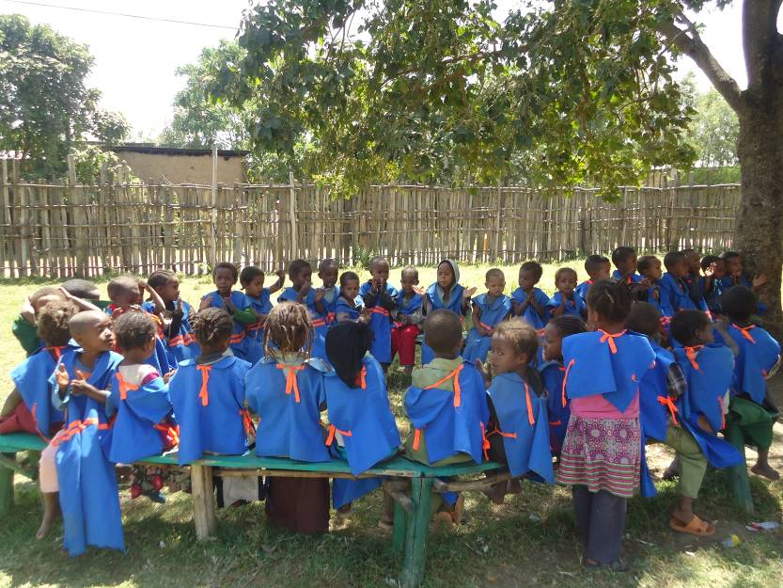
- “Guidelines for Early Childhood Care and Education” to guide stakeholders implementing ECCE services.
- To support the implementation of the policy framework, a strategic operational plan was developed “Strategic Operation Plan for Early Childhood Care and Education”

ECDE situation - The policy document acknowledges that ECCE is one of the most neglected areas in Ethiopia. A situation assessment study in 2007 found that the national early childhood education enrolment rate in 2007/2008 was only 3.9%. A number of agencies including government, communities, NGOs, faith-based organisations and the private sector were trying to offer ECD services, however, a number of challenges and weaknesses remained. These included lack of standard curriculum and guidelines, lack of proper training of ECD teachers, high payment that is requested for preschools and lack of alternative care and educations services for the majority of children in rural areas and those from low social economic backgrounds. This was further affected by lack of awareness about the value and type of care and education for young children and misconceptions about teaching children “because they are children”.

Methodology of the baseline

2.1 Design, sampling, preparation, and data collection
This baseline was a cross-sectional study that used both quantitative and qualitative methods for data collection plus a documents review. The quantitative component included a household survey and a child survey among ECD-age children in school (i.e., 6 to 8 years of age and in school). The qualitative component of the study involved key informant interviews (KI) with relevant leaders at district and kebele level where the CCCP is being implemented. The design and implementation of the survey was done in consultation with the CCCP regional team, national office teams and with participatory input from the CCCP partner in Siraro – the Siraro Children and Family Development Association (SCFDA). The baseline survey process, analysis and report writing was led by Creative Research and Evaluation Centre, Uganda.

Sampling strategy, sampling frame and sample size
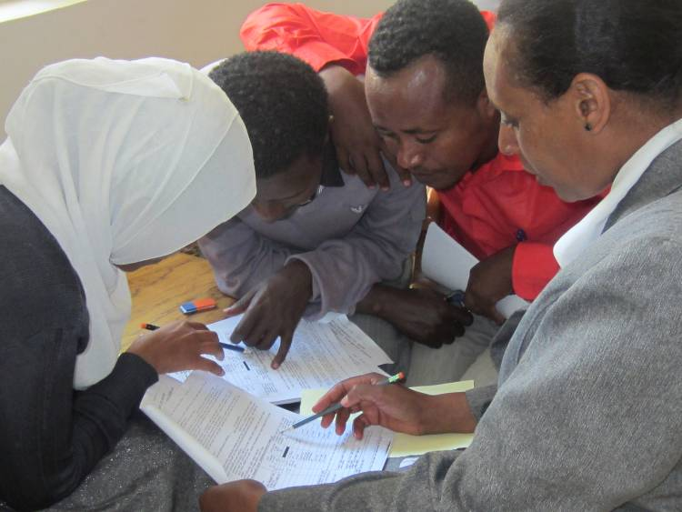
Lot Quality Assurance Sampling Strategy (LQAS) was nominated by ChildFund for use in the quantitative components of the Baseline survey. The advantage of the LQAS was the possibility of using relatively small numbers to generate meaningful information about individual wards and the whole project area as well as generating information that could be used for local monitoring. A convenience and judgmental sampling strategy was used to identify respondents for the qualitative key informant interviews in ECD facilities, primary schools and district/local government departments.

Data achieved and information sources - Unique tools for data collecting were designed and used for each category of respondents. Significant effort was invested in preparation of the collection tools and training field teams; and both teams and tools were pre-tested before the main data collection.

The data collection exercise was largely successful; most of the planned data was collected. In Siraro, however, a work stoppage by the data collection team on the final day of data collection reduced the targeted supervision areas from 5 to 4 and number of households from 125 to 100. Nevertheless, a sufficient amount of good quality data was available for analysis from which generalisations can be made about the CCCP programme area. [See annex 2 for list of communities and institutions that participated in the survey. Detailed quantitative information for each country is contained in Volume II of the Baseline Survey report.]
Reliable sources of information were available to the survey team at the household and for the key informant interviews. In the majority of households, information was provided by either the spouse or the head of household (92%). At the ECD/Zero class and Grade 1 class, the information was obtained from the teachers in charge.
Table 1: Data collected and analysed for the baseline
 | Siraro District | Alemtena Sirbo | Boye Awarkasa | Damine Leman | Ropi 01 | Ropi Sinta
Total households visited | 100 | 25 | 25 | 25 | 25 | -*
ECD age pupils (4 to 6 yrs) | 127 | 32 | 24 | 24 | 24 | 23
Grade 1 age pupils (6 to 8 yrs) | 103 | 24 | 26 | 28 | - | 25
Zero class/ECD teachers | 10 | 2 | 2 | 2 | 2 | 2
Grade 1 teachers and facilities | 9 | 2 | 2 | 2 | 2 | 2
Village profile | 5 | 1 | 1 | 1 | 1 | 1
Kebele government interviews | 5 | 1 | 1 | 1 | 1 | 1
*Note: It was not possible to collect household data from Ropi Sinta kebele during the course of this baseline survey

2.2 Limitations and challenges of the baseline survey
Sampling - Many of the indicators identified in the programme documents have different denominators, e.g., children 1 year olds, children 3-5 years, children 6 to 8 years, parents/caregivers and households. In order to get an adequate sample size for each of the different denominators at household level and for all the different age categories would have necessitated parallel samples for multiple categories. Doing so would have significantly increased the logistical demands and expenses for this survey. So for some sub-categories the numbers are small.

The baseline survey targeted households with children 0 to 5 years. The characteristics of the households that met the sampling criteria will, therefore, not be identical to those in secondary documents that are based on a census sample of the general population.

Data collection - It was challenging to collect reliable data on nutrition status for each of the three anthropometric measurements used in this survey. The more accurate digital tools for measuring weight were more expensive than the resources available to the survey. Instead, the survey used the Salter scale in Siraro (also for Mozambique, while the SECA 762 dial scale was used in Uganda). Each scale type presented different challenges. For height, the more ideal height/length boards for children are very bulky for transporting between households and only demonstration samples were available in each country. The survey opted to use the more portable SECA 208 body meter anthropometric tapes to measure height/length of children. Height measurements were not done for children under 6 months. Weight was not taken for children over 3 years in Siraro because of the limited sizes of weighing pants. As such, only a fraction of the targeted data is available for anthropometric calculations.

Under-reporting of sensitive issues - The proportions of households with chronically ill persons or persons affected by AIDS may actually be higher than is reported in this baseline because of cultural stigma associated with talking about HIV/AIDS. In Siraro, despite the fact that the data collectors were predominantly health workers, they refused to ask directly about HIV and AIDS affected persons in households.

As in other countries, the field teams in Siraro met with reluctance among respondents to talk about domestic violence. Because of this sensitivity, the occurrence of domestic violence is likely to be higher than what was actually mentioned to the interviewers. Similarly, the survey team feels that violence toward children and child abuses were probably under-reported both at home and at school.

2.3 Note to reader: How findings are presented
This report presents the key findings for the baseline from the programme implementation area in Ethiopia, which is Siraro District. The presentation of the baseline findings starts with the demographic and social economic status of households, then household vulnerability, child vulnerability, early childhood care and support at home, followed by enrolment and attendance in ECD facilities and primary schools and ends with a review of the ECD services and facilities in the 5 kebeles. The report ends with competency assessment of children in ECD and Grade 1.
Each section presents the findings from the field, main conclusions and potential implications of these findings. Information from quantitative and qualitative methods is presented together.
In addition to this report, other documentation for the baseline includes:
  - Overall report that compares the results from the three countries
  - Quantitative and qualitative data sets and data collection tools [to be archived for comparisons at the time of subsequent end of phase/endline studies or other analysis]
  - Field process documentation, including training reports, debriefing reports, sampling strategy, etc. [as knowledge products that can inform other studies by ChildFund]

Settings and demographics

3.1 Context: Siraro Woreda/District [from literature]
Siraro Woreda is a rural drought prone, densely populated area located 325km from Addis Ababa in West Arsi Zone of Oromia Regional State. Siraro district covers an area of 599.35 km² with a total population of 196,964 (M=96,512, F=10,452) with 94% in rural. The crude population density of the district was 127.8 persons per square kilometre. Life expectancy at birth for women and men is 60 years and 57 years respectively. About 50% of the district’s population is below 15 years of age Current district estimates for different age groups of are children are: under 1 year=6,244; under 5 years= 32,361 and children 6-15 years=70,828; gender proportions of males 49% and females 51%).

The majority of the population live in the rural part of the district and are dependent on subsistence rain fed agriculture. Food shortages and low income are prevalent in the district. This in turn results in limited access, affordability and attendance of health and education services including ECD education. (CCCP Programme document, 2012; Siraro District planning data 2012 and www.oromiyaa.com)

In Siraro District the status of early childhood care is generally poor. In 2010, birth registration was low, with only 6.3% of children aged 0-23 months and 2.1% of those aged 24-59 months reported registered. Early childhood education attendance was low, only 6.3% of children between 3 and 5 years attend some form of early childhood education program (child care centres, nurseries, pre-school and kindergarten programs). In-house support of children in their pre-school learning was also low, only 10% of parents engaged in activities that promoted pre-school learning. (ChildFund’s Ethiopia Area Strategic Plan, 2010).

3.2 Communities & infrastructure [from survey]
The CCCP Baseline survey 2012 was done in 5 out of ## kebeles in Siraro District namely: Alemtena Sirbo, Boye Awarkasa, Deman Leman, Ropi 01 and Ropi Sinta.

Travel means - In most villages, the commonest mode of transport is walking on foot. There is very little public transport in the area, and where it exists, it is usually available on only during market days in a few kebeles like Ropi town and Alemtena Sirbo. To reach a public transport point, household members are compelled to walk anywhere from half an hour up to a maximum of six hours. Donkey/horse carts are used to transport market/produce. Road conditions in most villages are seasonal; only a few kebeles have an all-weather gravelled road, e.g., Ropi 01, Damine leman and Ropi Sinta.

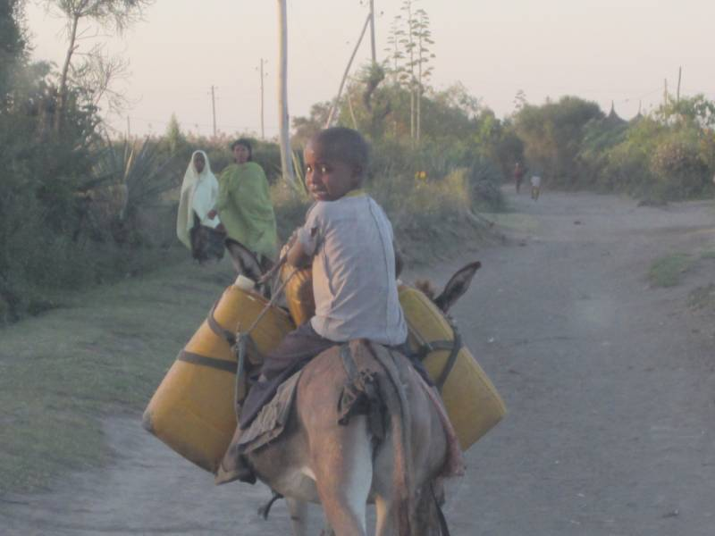
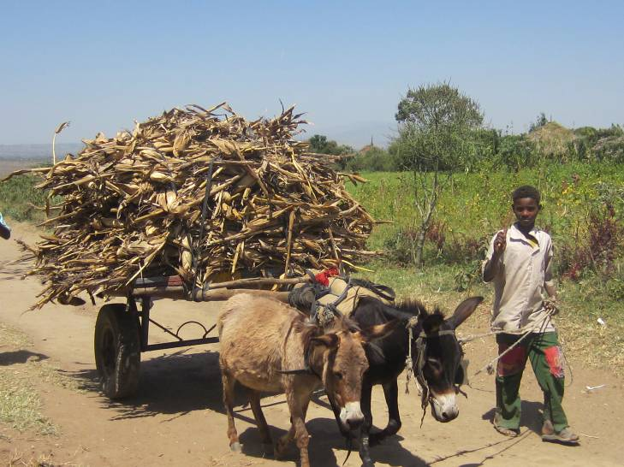

Public infrastructure – As with roads and transport, other public infrastructure in Siraro is generally very limited (see table below). Infrastructure for health and rights protection is even more limited than education infrastructure. While most of the communities (7/11) had ECD and primary school facilities, only one had a secondary school, only two had a child protection facility, and only three had a health facility. Of the available infrastructure, government is the main provider for the education, health and rights protection services.
Table 2: Infrastructure within the villages/communities
Kebele | Village name | Pre-school? | Primary school | Secondary school | Health units | Health outreach | Rights protection
Alemtena | Zone 2 | 0 | 0 | 0 | 0 | 0 | 0
Alemtena sirbo | Zone 3 | 1: Zero class, Govt | 1: 1-8 grade | 0 | 0 | 0 | 0
Boye awarkasa | Zone 1 | 1: Govt | 1: Govt | 0 | 1: Govt | 1 | 0
Boye awarkasa | Zone 3 | 0 | 1: Govt | 0 | 0 | 1: Under tree | 0
Ropi 01 | Zone 1 | 0 | 0 | 0 | 0 | 0 | 1: Govt
Ropi 01 | Zone 3 | 1: Govt | 2: 2 cycles | 1: 9-12 grade | 5: 1 Govt,  4 Pvt | 1: Use HC | 1: Police
Damine leman | Zone 1 | 1: Govt | 1: - Govt | 0 | 0 | 1: At HC | 0
Damine leman | Zone 3 | 1: Zero class, Govt | 0 | 0 | 0 | 0 | 0
Biftu Siraro | Biftu Siraro | 1: Zero class, Govt | 1: 1-8 grade | 0 | 1 | 0 | 0
Ropi Sinta | Zone 1 | 0 | 0 | 0 | 0 | 1: Under tree | 0
Ropi Sinta | Zone 3 | 1: Zero class, Govt | 1: 1st cycle 7 to noon | 0 | 0 | 0 | 0

The distribution of infrastructure within kebeles is also variable.

3.3 Household demographics

Head of household and primary caregiver
The baseline survey targeted households with children 0 to 5 years and also asked about children 6 to 8 years in the sampled households. Below are the characteristics of the heads of household and the primary caregivers for the households that met the sampling criteria [i.e., these households are not the same as a census sample of the general population].

Head of household
Heads of households are mostly males (97%) and over 18 years; with a mean age of 37.6 years and 35 years median. Some households had vulnerability characteristics associated with the headship of the household, for example, where the head of household was non-literate (70%), female (3%), or elderly (over 64 years) (1 %).

Primary care giver
Primary care givers are almost all females (99%) and over 18 years; with a mean age 27.7 years and median 28 years. In general, the primary caregivers were younger than the heads of households; a small proportion of primary caregivers (6%) were over 64 years.

Table 3: Characteristics of the head of household and the primary caregiver
About the head of household | Siraro
Gender of head of household | N=100
Male | 97%
Female | 3%
Age of head of household | N=54*
Mean (in years) | 37.6
Median (in years) | 35
Range (in years) | 24 to 70
Literacy of head of household | N=100
Not literate | 70%
Literate (reads & writes with meaning & understanding) | 30%
Language of literacy for head of household | N=100**
None | 70%
Amharic | 21%
Oromifa | 13%
About the primary caregiver | Siraro
Age of primary caregiver | N=53*
Mean (in years) | 27.7
Median (in years) | 28
Range (in years) | 18 to 62
Gender of primary caregiver | N=100
Male | 1%
Female | 99%
Relation of caregiver to head of household | N=100
Household Head | 0
Spouse (Wife) | 91%
Son or daughter | 8%
Other relative: parent, sibling, grandchild | 1%
Literacy of primary caregiver | N=100
Not literate | 91%
Literate (reads & writes with meaning & understanding) | 9%
Language of literacy for primary caregiver | N=100**
None | 91%
Amharic | 8%
Oromifa | 2%

Literacy was even lower among primary caregivers (at 91%) than heads of household (70%); i.e., less than 1 in 10 caregivers was literate and therefore able to read health and education messages. Non-literate parents (heads of household and primary care givers) may be less likely to from early stages in their children’s education and may be limited in their knowledge of ways to stimulate their children’s literacy and numeracy abilities.

Implication: The CCCP should strongly consider advocacy for adult literacy programme/classes including for parents and caregivers. Such literacy classes could be used to share additional information and skills, e.g., parenting education.

Distribution of children in the sampled households
The survey targeted households with children 0 to 8 years. As expected the younger age group was more prevalent. There were almost equal proportions of children in the 0 to 3 and 3 to 6 age-groups.
Table 4: Children in the household 0 to 8 years of age
About children in households | Siraro
Children 0 to 3 years | (n=100)
HH has children 0 to 3 years | 83%
Numbers of children in HH | All | Male | Female
HH has children 0 to 3 years | 111 | 47% | 53%
Relation to head of household | All | Male | Female
1 Son or Daughter | 97%
2 Nephew or Niece | 2%
3 Grandchild | 0
4 Brother or Sister | 0
96 Other, Unclear, don’t know | 1%
Children 3.1 to 6 years
HH has children 3.1 to 6 years | 78%
Numbers of children in HH | All | Male | Female
HH has children 3.1 to 6 years | 93 | 47% | 53%
Relation to head of household | All | Male | Female
1 Son or Daughter | 94%
2 Nephew or Niece | 3%
3 Grandchild | 1%
4 Brother or Sister | 2%
96 Other, Unclear, don’t know | 0
Children 6.1 to 8 years
HH has children 6.1 to 8 years | 29%
Numbers of children in HH | All | Male | Female
HH has children 6.1 to 8 years | 30 | 40% | 60%
Relation to head of household | N=30 | Male | Female
1 Son or Daughter | 93%
2 Nephew or Niece | 0
3 Grandchild | 0
4 Brother or Sister | 7%
96 Other, Unclear, don’t know | 0

3.4 Household livelihoods

Household income strategies
The main income producing activity in Siraro district is agriculture; this includes mixed food crop farming and livestock rearing/fattening, supplemented by business/petty trading. Household level interviews confirmed that there is little diversity among households; income strategies are mostly agricultural-based and informal.

Household assets and asset profile index
The CCCP has targeted several ways of addressing barriers to ECD, including increasing household assets through the VS&L component. This baseline gathered information to benchmark current assets available to the sampled households, including main house roof type, livestock and transport owned by households.

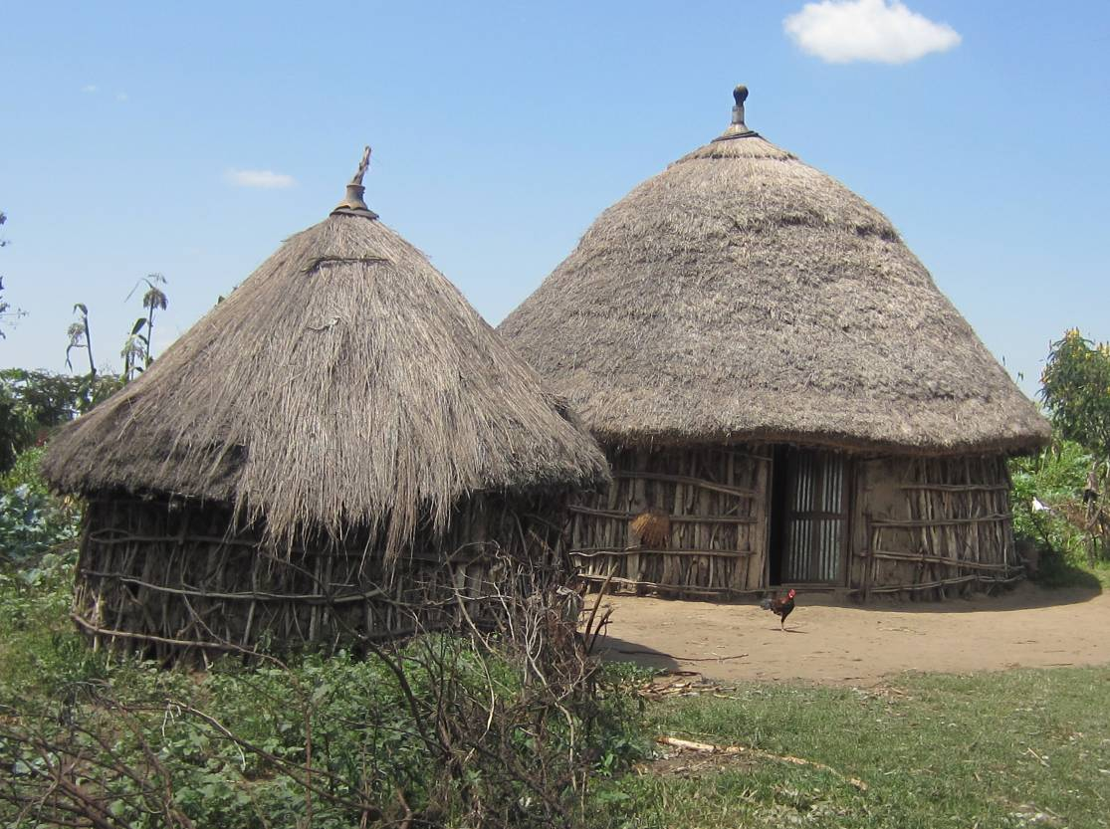

Note that this survey did this look at house/land ownership, vs renting, etc.
Table 5: Household assets and asset profile score
 | Siraro |  | Non-literate HoH | Literate HoH
 | N=100 |  | (n=70) | (n=30)
Roof type
- Grass, leaves, banana fibre roof | 79%
- Iron sheets, metal roof | 20%
- Other canvas/tarpaulin/polythene | 1%
Livestock
- Household owns livestock Yes | 56%
Type of livestock owned****
- None | 44%
- Cows/bulls | 41%
- Goats/sheep/pigs | 20%
- Poultry | 16%
- Donkey/mule/horse/ | 18%
Household owns transport means
- Yes | 17%
Type of transport means owned****
- None | 83%
- Bicycle | 7%
- Cart donkey/horse | 11%
- Motorbike, car/pick-up/lorry | 0
Asset profile score** |  |  | (n=70) | (n=30)
- 1 (grass thatch, no livestock, no transport) | 28% |  | 33% | 17%
- 2 (grass thatch, own chickens, or owns bicycle) | 16% |  | 14% | 20%
- 3 to 4 grass thatch with some poultry &/or grass thatch with a bicycle Or metal roof with poultry &/or bicycle | 23% |  | 19% | 33%
- 5 to 6 (grass thatch with some livestock usually sheep/goat or cows | 12% |  | 14% | 7%
- 7 to 15 (Grass or iron sheet roof, & variety of livestock &/or means of transport) | 22% |  | 20% | 22%
**** Some households had more than 1 form of transport or more than 1 type of livestock
** Values were assigned to each of the above assets as follows:
Roof: grass thatch=1; iron sheet=3; tile=3
Livestock: none = 0; chicken=1; goat/sheep/pig=2; cow=3
Transport means: none=0; bicycle=1; motorbike =2; car/pick-up=3
Using the above score card, a total asset profile score was made for each household.

Using the list of assets, a locally derived composite asset profile index was created for households visited in this baseline. Note that this asset profile was used to document range of assets and number and quality of these assets was not assessed. The asset profiling showed a mixed picture for Siraro. About a quarter of the households were at the lowest level of the asset profile, i.e., they hand only a limited range of assets - house with temporary roofing and no livestock or transport means. While a quarter of the households were the highest level of the asset profile , i.e., they had a house with permanent roof, had a variety of livestock and a range of transport means .

In Siraro, literacy of head of household did not seem to affect the asset profile, except for the lowest profile where the proportion of non-literate was twice that of literate ones.
Of the 3 female headed households, 1 was in the lowest and 2 were in the highest level.

Accessing and using credit
Proportions of households that had received financial credit or credit-related information and services (since January 2012) was very low (4%) in Siraro district.
Table 6: Households accessing credit services
Accessing and using financial credit | Siraro
Household received credit related information, visits or services in past 12months | N=100
- Yes | 4%
Type of service | (n=4)
- Loans | 4/4
- Training | ¾
- Food, maize | ¾
- Loans and savings union | ¾

Implications: there did not appear to be any tradition of self-help financial groups, which, if verified, may present challenges to the VS&L strategy. At the same time the VS and L strategy could build onto the widely available idir groups.

Household vulnerability
The survey checked about the extent of household vulnerability from local leaders and at household level. While leaders know that there are vulnerable individuals and households within their communities, many of them were not aware of specific numbers and/or proportions of vulnerable households, for example, households with orphans or AIDS-affected people, female-headed households, or households headed by elderly persons. One leader even said that there were no orphans in his Kebele.

In addition to the above, local leaders also reported other kinds of household and community vulnerabilities. One such vulnerability was excessive alcohol use and abuse, especially among males and unemployed youth; this was reportedly common in all five kebeles. The leaders said that unemployment among young men contributes to alcohol abuse, which in turn made their families most affected. Another related problem in the community is chewing chat, which is a mildly addictive stimulant drug that has become increasingly popular in Siraro in the past few years.

Implication: lack of accurate information makes it difficult for leaders to plan and advocate for the vulnerable in their communities. There are also forms of vulnerability in the community that were not fully explored in this baseline, due to the limitations of the study, but could potentially be significant factors affecting household and community investments in child welfare.

At household level, the survey asked specifically about issues linked to household vulnerability: sources of income, sources of funds for services, food security, water and sanitation facilities, social group membership, engagement in local leadership, and presence of vulnerable persons.

4.1 Economic poverty
Sources of income for health and education costs – Household respondents said that their sources of cash to cover health and education costs are similar to their sources of income, i.e., principally from crop farming. Meanwhile, income options are limited and about one-third of households (34 %) report having only one source of income and another 31% listed animal farming for their secondary income sources.
Table 7: Household income and sources of money for education and health costs ET
Siraro | Source of income |  |  | Source of funds for services
 | 1st income | 2nd income |  | Education costs** | Health costs
 | N=100 | N=100* |  | N=100* | N=100*
Crop farming, Selling crops, produce | 80% | 9% |  | 56% | 61%
Petty trade, small business, vendor, | 11% | 13 |  | 6% | 14%
Animal farming, sell animals and products | 3% | 31% |  | 7% | 16%
Casual labourer, various daily tasks | 2% | 7% |  | 1% | 6%
Skilled artisan: carpenter, tailor, mechanic, formal employment | 1% | 1% |  | 0 | 2%
Borrow: friends, relatives, Group, SACCO Remittances | 2% | 2% |  | 2% | 6%
Support from CSOs, NGOs | 1% | 2% |  | 8% | 1%
Other (specify) | 0 | 1% |  | 0 | 2%
None (no secondary sources) | 0 | 34% |  | 29%*** | 0
*% more than 100, 9 households had 2 sources of money for schools costs
**% more than 100, 8 households had 2 sources of money for health costs
*** 29 HH did not have any children going to school, so no current education costs

There were two items in paying for services that did not follow the general trend in sources of income. First, about 8% of households (1 in 12) rely on support from CBOs/NGOs to cover education costs. Second, to cover health costs, about 6% of households said that they have to borrow from family/friend and other social groups.

4.2 Food security/insecurity
The survey asked about the occurrence of food shortages at household levels resulting in households having to cope by reducing the amounts of food eaten or frequency of meals. This survey found that food shortages were especially high in Siraro. Almost all of the households sampled (91%) reported having food shortages for a month or more within the past one year.
Table 8: Household vulnerability – households reporting food shortages
 | Siraro
Households food shortages (in a12 month recall) | N=100
Yes , Households reporting food shortages | 91%
Number of months without sufficient food
- 0 | 9%
- 1 to 2 | 7%
- 3 to 4 | 55%
- 5 to 6 | 19%
- Over 6 months | 10%
Number of months of food shortages | (n=91)
- Mean (months) | 4.3
- Median (months) | 4
- Range (months) | 1 to 10

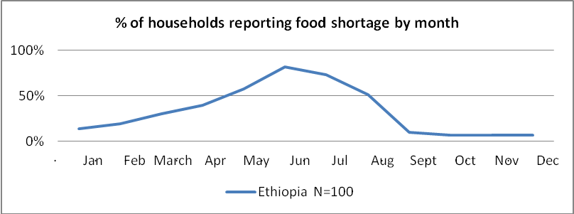

Implication: hunger can be a double barrier to education, either preventing attendance because children are mobilised to help support family efforts to get food, or because their attention and performance decline even if they get to school.

4.3 Water, sanitation and hygiene

Drinking water sources and handling
From the village profiles, there is a mixture of safe and unsafe water sources available for domestic use. The commonest water sources were: public taps, ponds, rivers and water vendors. In Siraro District, some of the sampled households had to travel up to 7 km to reach a water source.
Kebele leaders from survey areas estimated that over half of the households have access to safe drinking water, which was confirmed in the survey.
In the household survey, the majority of households (80%) reported using a safe water source for drinking water (mostly piped water to a public tap).

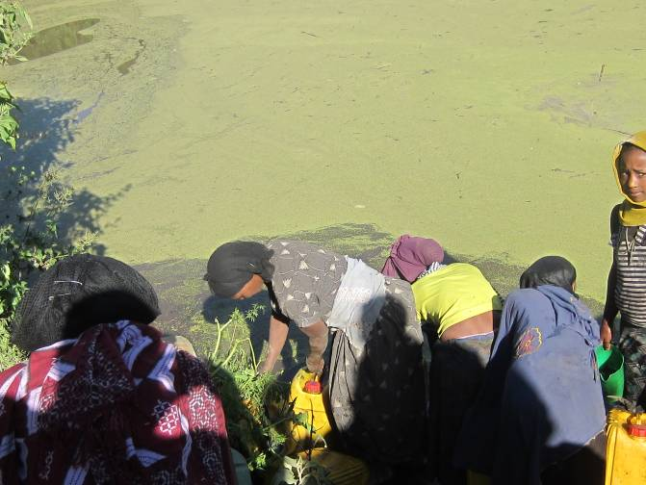
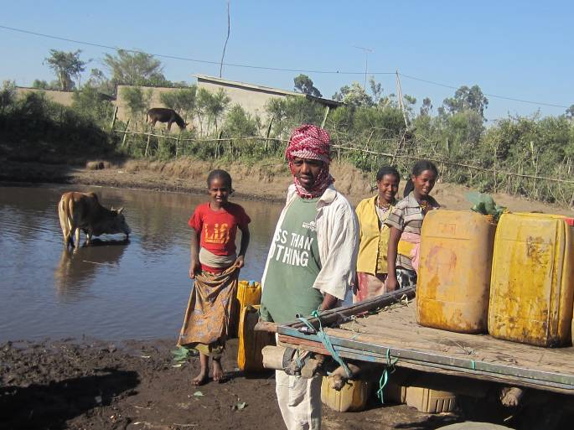

Only 37% of households do something to make their drinking water to it safer; the most common practice of this kind (11% ) was using chlorine tablets/solution.
Table 9: Drinking water: main source and water handling
Types of MAIIN drinking water sources | Siraro
Type | N=100
Protected water source: Piped, borehole, | 80%
Unprotected water source: pond, well, spring, | 20%
Water sources used by HH for drinking | N=100*
Piped water Public tap** | 75%
Borehole, Protected well, Spring | 5%
Unprotected well or Spring | 0
Surface water – river, lake, | 18%
Collected Rain water | 2%
How HHs make drinking water safer? | N=100
Do Nothing | 63%
Add Chlorine tabs, solution | 11%
Strain, filter water | 19%
Boiling | 7%
Let it stand and settle, Leave in the sun | 0
*In Siraro 38% of households had a 2nd main water source, especially used in the rainy season

Only 3% of households reported having a container to collect and store rain water (1 concrete tank, 2 plastic tanks). Despite the limited availability of safe water points reported long distances to available safe water points, investment in domestic rainwater collection was very low, almost negligible.

Sanitation: Latrine ownership and quality
Latrine ownership by households was modest in Siraro; about two-thirds of the households (69%) reported they owned latrines. Sharing of latrines is fairly common; 17% of households with latrines were sharing their latrines with at least one other household.

The quality of available latrine facilities, however, was low. Using the sanitation ladder only 2% of households in Siraro had improved latrines (VIP ventilated improved pit latrine or latrine with concrete/cement slab). Beyond the latrine structure, very few households had any hand-washing facilities and supplies in or near the latrine facilities; only 6% of latrines had hand washing facility in or nearby. Of the total households sampled, only one household (1%) had a latrine with water and soap nearby at the time of the survey.

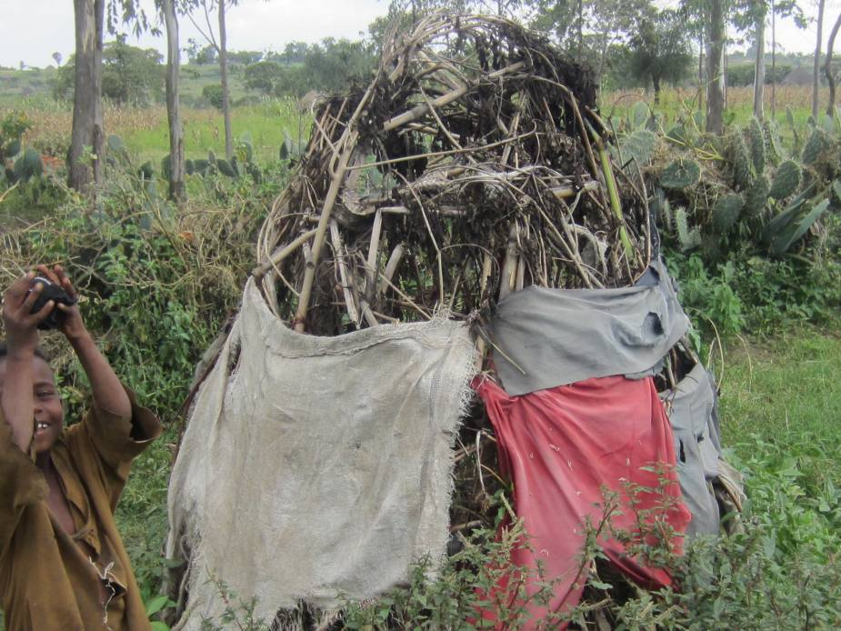

Table 10: Sanitation, latrine facilities at households
 | Siraro
 | N=100
YES, HH owns latrine (Any) | 69%
% HH with improved latrine | 2%
Type of latrine facilities (ALL Households )
- Ventilated improved pit latrine VIP | 0
- Pit latrine with Concrete slab | 2%
- Pit latrine with MUD slab | 18%
- Pit latrine, no slab pit with logs | 49%
- NONE, no latrine | 31%
Shared latrine facilities | (n=69)
NO, Latrine not shared | 83%
YES, Latrine shared | 17%
How many HH shared latrine | (n=12)
1 | 1/12
2 | 1/12
Not specified | 10/12
Hand washing facility at latrine | (n=69)
YES, has Hand-washing facility | 6%
NO, Hand-washing facility | 94%
State of hand washing facility | (n=4)
Has water | ¾
Has soap | ¼
Has water and soap | 1/4
Literacy of head of households did not appear to affect latrine ownership – 69% of households with non-literate heads had latrine compared to 70% literate ones. The three female headed households had latrines.
Implications: Absence of hand-washing facilities, soap and water to wash hands after latrine use poses a high risk of contamination through faecal-oral transmission . Simple, low-cost solutions like Tippy Taps (made by stick, rope and plastic container) are within the financial and technological reach of even the poorest communities and greatly reduce this risk.

Why some households have no latrines
In Siraro, the most common explanation that people gave for not having a latrine was ‘lack of timber for construction’. However, non-caring attitudes, misconceptions and laziness are contributing to no latrines, for example, not aware of benefits; no husband refused/ lazy; fear catching disease in latrine.
Table 11: Why households do not own latrine
HHs with no latrine | Siraro
Why NO Latrine | N=31
No logs, no timber for latrine construction | 42%
Share with neighbour | 13%
No place, no land to build latrine, in rented house | 13%
Old one destroyed, Old one full not replaced yet | 10%
Husband away, Husband refused, Husband lazy | 10%
No aware of benefit, Not ready to dig, no need | 6%
Fear snakes in latrine, Catch diseases in latrine | 6%
Other | 3%

Hygienic disposal of children’s faeces
The survey also checked on how caregivers disposed of stools for children young than 3 years. While the majority of caregivers (51%) reported safe disposal of young children’s stool (in a latrine) some households practiced unsafe disposal; leaving the faeces in the open or putting them in garbage/ditch/drain 32%.
Table 12: Disposal of faeces for children under 3 years of age
 | Siraro
Method of disposal | N=83
Child used latrine | 11%
Put into latrine | 51%
Dug a hole, Buried | 6%
Put/rinsed in drain/ditch, throw in garbage | 20%
Nothing, Left in the open | 12%
Note: **N=Households that had children under three years of age

Implication: based on local practices, there was considerable risk of contamination of food and water sources in these locations and households, contributing to the occurrence of diarrhoeal diseases. Caregivers in this region may not be considering children’s stool to be a dangerous source of contamination.

Hand washing with soap at critical moments
To assess awareness and practice of hand washing, the survey asked an open question to caregivers of children (3 years and younger) on when they washed hands with soap. The responses were then sorted to determine how many caregivers mentioned washing hands with soap at:
- Two critical moments - before eating, after defecation OR after cleaning a child’s stools.
- Three critical moments - before eating, after defecation AND after cleaning a child stools.

In Siraro, the proportion of caregivers that reported washing hands with soap at two critical times before eating and after defecating and/or after cleaning a child was low (25%). This proportion drops further (to 5%) when we checked on washing at all critical 3 critical times - before eating, after defecating and after cleaning child.
Caregivers reported washing with soap commonly before preparing food (72%) and before eating (58%) and less after defecating (31%) or after cleaning a child’s stool (19%). In general, very few caregivers reported washing hands with soap after cleaning a child.
Table 13: Hand washing practices with soap
When did the main caretaker in HH with wash hands with soap? | Siraro
When did the main caretaker in HH with wash hands with soap? | N=83**
Before preparing food | 72%
Before eating | 58%
After handling dirty stuff, when hands dirty | 42%
After defecating | 31%
Before feeding others | 29%
After cleaning child | 19%
After eating | 17%
Never use soap, rarely have soap, when soap is available | 10%
Others - any time, all the time, when leaving home, before going to sleep, on waking up | 0
Washing hands with soap at 2 or 3 critical times*** | Siraro
At 2: Before eating, After defecating OR after cleaning child | 25%, 21/83
At 3: Before eating, After defecating AND after cleaning child, | 5%, 4/83
**% calculated using households with children under3 years of age as denominator

Comment from the literature: Hand washing with soap is among the most effective and inexpensive ways to prevent diarrheal diseases and respiratory infections which together are responsible for the majority of child deaths. Making this simple practice an entrenched habit could save hundreds of children’s lives, contributing significantly to MDG 4 - reducing deaths among children under the age of five by two-thirds by 2015. Hand washing with soap also reduces the incidence of skin diseases and eye infections like trachoma. Although people wash their hands with water, very few wash their hands with soap at all critical moments (for example, after using the toilet, after cleaning a child’s stool and before handling food). Washing hands with soap at these critical times can reduce diarrheal disease, including cholera and dysentery, by 48-59% and rates of respiratory infection by about one-quarter.

4.4 Presence of vulnerable persons in households
Some households had additional vulnerabilities, such as the presence of orphans or chronically ill persons. In Siraro, 10% of households reported taking care of at least one orphan in the household and 4% were caring for a chronically ill person or a person living with AIDS in the household.
Table 14: Household vulnerability – households with orphans or chronically ill person
 | Siraro
Household has orphans? | N=100
- 0 | 90%
- 1 | 4%
- 2 | -
- 3 to 4 | 3%
- Number of orphans not specified | 3%
Household has chronically ill persons, persons ill with or died from AIDS? | N=100
- 0 | 96%
- 1 | 1%
- Number not specified | 3% | - |  | -

Implications: Caring for orphans and for sick family members increases demands for family time and other resources and may compromise investments in health and education for children.

4.5 Social group membership
Not quite half (41%) of all of the sampled households reported that one or more members of the household belonged to some kind of social group. Almost equal proportions of males and females reportedly belong to social groups. Regarding the types of social groups, the most common (88%) were the prevalent form of mutual support groups in Siraro, called Idir. The top three activities for groups were mutual support (helping out one another in good and difficult times); saving and sharing/ borrowing money, business and farming activities.

Benefits from social group membership – Households with members in social groups were asked about the benefits for the household from the social group membership. Most commonly, the respondents said that membership was associated with improved household incomes and wellbeing and improved ability to cover health and/or education costs. The top benefits were: helping one another (86%); improving household wellbeing and income (20%); and getting loans (17%). A few households (10%) said that there were no benefits from social group membership (yet).
Table 15: Households engaged in social groups
Social groups membership and activities | Overall | Siraro
Social groups membership and activities |  | N=100
- Yes, at least 1 household member belonging to a social group |  | 41%
Gender of people in social groups |  | (n=57)
- Male |  | 54%
- Females |  | 46%
Type of group |  | N=57
- Self-help mutual support groups (Idir in Siraro) |  | 88%
- NGO linked groups including CF, CFDA in ET |  | 5%,
- Women association in Kebele |  | 4%
- Union for buying crops – WOLDA |  | 2%
- Old people association |  | 2%
Main activities of the group |  | N=57
- Self- help; Helping one another |  | 47%
- Saving money and sharing to solve problems, for loans |  | 35%
- Trading Buying and selling crops, etc. |  | 16%
- Farming activities |  | 4%
- Child development activities |  | 2%
- Not specified |  | 2%
Household benefits from social group membership |  | (n=41)
- Help one another, e.g., in marriage, illness, death, etc. |  | 86%
- Improve household livelihood & wellbeing, e.g., income, housing, basic needs, means of getting income, milling machine, etc. |  | 20%
- Get loans |  | 17%
- Learn saving culture |  | 5%
- Sharing food |  | 2.4%
- Other |  | 5%
- None, no benefit yet, still new |  | 10%
Implication: in contrast to the information arising from the household assets and coping strategies, this information suggests that VS&L approaches may be viable, but they may have to be adapted to fit with the prevalent cultural norms and patterns of the Idir groups.

Engagement in local leadership
The proportion of households with members engaged local leadership roles was very low; only 4% of households reported family members leadership roles (i.e., ten times lower than social group membership). There is a greater representation of males in the leadership positions, than females. Although the representation was low, the types of institutions in which leadership positions are held included education and water.
Table 16: Households engaged in local leadership
Local leadership activities | Siraro
 | N=100
Yes, at least 1 household member with local leadership role | 4%
Gender of person engaged in leadership | (n=4)
- Male | ¾
- Female | ¼
Type of institution | (n=4)
- Education – ECD facility, primary, sec sch | ¼
- Water committee | ¼
- Women association | ¼
- Unknown, not listed | ¼
Leadership position held | (n=4)
- 1 Coordinator, Leader at community level | ¾
- 3 Secretary | ¼

Implications: While social group memberships is often voluntary and self-mobilized, leadership positions are often appointed or elected. This may limit engagement in leadership, especially where competencies like literacy are very low or females are disadvantaged, both of which seem to be the case in Siraro. As such, the programme may have to be creative in mobilising caregivers (mostly female and illiterate) into positions of leadership and decision-making around the ECD needs of young children.

4.6 Exposure to domestic violence
The mentioned occurrence of domestic violence was relatively low; about one in 8 households (13%) said there had been at least one incident in a 12 month recall period. As in other countries, the field teams met with reluctance for respondents to talk about domestic violence. Because of this, the occurrence of domestic violence is likely to be higher than what was described. In fact, during fieldwork one violent incident was witnessed by the survey team, suggesting that it may be much more common than people were willing to talk about. More than half of the described incidents had occurred within the past three months.

The domestic violence described in Siraro was most commonly physical and verbal, and involved the household head and the spouse. The commonest cause of conflict was food related and mismatch of expectation between males and females in the household. The majority of domestic violence incidents were not reported to any authorities.
Table 17: Household vulnerability – households report incidents of domestic violence
 | Siraro
Households reporting domestic violence | N=100
- Yes | 13%
Type of violence? (incidents ) | N=17
- Physical - Beating, fighting | 11/17,
- Verbal – Quarrels, Abuses | 6/17,
Who were involved? | N=17
- Children of the household with parents | 9/17
- Husband and wife, Head of house and spouse | 8/17
Cause, predisposing factor to violence? | N=17
- Conflict around expected gender roles, e.g., Female/Wife not fulfilling responsibility; because of food delay, Female not washing dirty clothes, Female delay to return home, | 17/17
When violent incident occurred? | N=17
- During month of survey | 6/17
- Past 1 to 3 months | 5/17
- More than 6 months ago | 5/17
- Others: Anytime, when drunk, Often, unclear | 1/17
Where was the violent incident reported? | N=17
- Neighbour | 10/17
- Relatives: elders, parents, in-laws | 1/17
- Nowhere, Not reported | 5/17

District records show that gender based violence is prevalent and that gender control of resources was a major point of conflict. In a in a 12 month period January and December 2012, 2 cases of physical violence and 30 cases of men controlling and taking women’ were reported. To cope with domestic violence the district respondents reported that – a multi-sectoral legal consulting group has been established at district level to work on community mobilization and awareness raising plus prosecuting those who violet child and women rights to penalty in collaboration with Woreda Police and Justice Offices.

Implication: there is a strong suggestion this survey and district data that the primary victims of domestic violence are female, i.e., that this is, in fact, gender based violence (GBV), not just domestic violence.
If the female caregivers in the household are going to be expected to expand their roles in the community and education facilities, then efforts will be needed to address household level expectations about their roles in order to avoid causing harm through the interventions.

Children’s vulnerability
The household survey specifically asked about children living with/separate from biological parents, birth registration, disability, child disciplinary practices, and rights violations.

5.1 Children separated from biological parents
In this survey sample, the majority of children 0 to 8 years (over 90%) were staying with their biological parents as the head of household.
Implication: the project may need to track carefully about the investment being made by families in children not living with their biological parents, as this represents close to 10% of all children. This will involve community assessments to check on ‘missing’ or ‘invisible’ children, not just tracking institutional records of who is attending at ECD centres or schools.
Comment from the literature: Child development is largely influenced by the family structure in which a child is raised. Children living without their mothers or fathers, or without both biological parents, are at special risk of being denied the care they need for their physical and psychosocial well-being. (Inequities in ECD, 2012)

5.2 Child identity: Birth records & birth registration
Record of birth – For child identity, the survey asked if children 0 to 3 years had any documentation to show a record of the child’s birth as a proxy for birth certification. Documentation of births was very low in Siraro; only 3% of children 0 to 3 years old had their birth registered and/or the family had documentation of the birth.
Table 18: Record of birth for children 0 to 3 years
 | Siraro
Child identity for 0 to 3 year olds | (n=83)
Does child have a record of birth?** asked for 0 to 3 year olds
- Yes | 3%
- No | 96%
- Don’t know, missing or unclear info | 1%
- Other – | 0
Why NO document for record of birth of the child | (n=70)
Top 5 reasons why some households had no record of birth | ET
- Child born at home | 1st
- Card lost, damaged, destroyed | 2nd
- Don’t know about birth registration, don’t know where and how to record birth | 3rd
- Not given, never gotten | 4th
- Forgot to register birth | 5th
- No time, it is a long process, parent busy, No money | -
**Definition used - A written document about the child’s, could also be child’s mother’s name stating the child’s birth details, for example, date of birth, place of birth, birth weight, from local authority , local health unit or registrar office

Reasons for missing record of birth - Exploring reasons for why a child had no birth documentation exposed multiple constraints to birth registration at different levels. The most common reason was childbirth occurring at home, and therefore not subject to official documentation. In an environment of very low literacy, this was also linked with lack of awareness about the registration process. Some parents even expected that the birth document would be automatically given. Even when parents have made the effort and recorded the birth; handling of the birth record documents/card was challenging, and many cards are have been lost or destroyed by water, fire, or eaten by vermin.

Implications: Interventions to improve birth registration will have to include strategies to increase awareness on the significance of birth registration, information on how to and where to register, and strategies to improve handling and security of child documents at household level to minimize loss and destruction.

5.3 Children with disability
The data collected on disability among children was only by report of the caregivers, and levels were so low that it is likely that many disabilities, especially in very young children, were either unrecognised or unreported due to cultural stigma. Only 1% of children 3.1 to 6years and 14% of children 6.1 to 8 years are reported to have disabled. Limb-related disability was the most common form of disability. Other less commonly mentioned forms of disability, such as learning disability, speech or language impairment, or serious emotional disturbances may be under-reported due to lack of facilities for diagnosis, as well as cultural barriers to acknowledging them.
Table 19: Children 0 to 8 years of age with disabilities
About children in households | Siraro
Children 3.1 to 6 years
Children with disability | All | Male | Female
0 = None | 99%
1 = Limbs | 1%
2 = Blind | 0
3= Deaf | 0
4 = Mental | 0
Children 6.1 to 8 years
Children with disability | All | Male | Female
0 = None | 86%
1 = Limbs | 7%
2 = Blind | 0
3= Deaf | 7%
4 = Mental | 0

Affordable quality child care is difficult to find for children with special needs. Many parents/ caregivers may be unwilling to send their disabled children to available ECD centres/schools and child-care providers may be unable or unwilling to enrol disabled children in their facilities (due to limited adaptations of physical facilities, or appropriately trained teachers to meet the children’s special needs).

5.4 Occurrence & management of child rights violations

Incidence of abuse and violence against children
Village leaders acknowledged that child abuse does occur in their respective villages; though documentation of occurrence and management was poor (e.g., on types, frequency, causes, offenders, reporting, consequences, etc.). Household respondents were asked if any of the children from the households had suffered any form of violence in the past three months, whether at home or outside the home. The majority of household respondents denied that any violence had occurred to the children of that household. Only 9% (9/100) of households reported the occurrence of any violence against children within the three month recall period. Similarly, there were very few incidents of violence identified during focus group sessions with ECD or grade 1 children.

The survey team feels that this is one area that was probably under-reported both at home and at school. When asked about how children are disciplined, however, some of the common means of disciplining children that are used in this region are violent. [see section below this on discipline]

Of the few cases acknowledged to be occurring, only a quarter (4/16, 25%) were reported, most often only to parents and sometimes to teachers. Child in focus groups confirmed that when they are treated badly by other children or adults, they commonly reported to parents and teachers.
Table 20: Households reporting and handling incidents of child violence
 | Siraro
Report of violence against children in the HH? | N=100
- No, no incidence of violence reported | 91%
- Yes | 9%
Sex of children affected | N=16
- Male | 7/16
- Female | 9/16
Age of children affected | N=16
- Up to 3 years | 4/16
- 3 to 5 years | 2/16
- Over 5 years | 10/16
Type of violation, abuse | N=16
- Caning, corporal punishment | 11/16
- Beating | 3/16
- Denial of food | 1/16
- Verbal abuse, shouting | 1/16
Where reported | N=16
- Parent: mother, father | 2/16
- Grandparent | 1/16
- Teacher | 1/16
- Neighbour | -
- Nowhere, not reported | 12/16
**More than 1 abuse reported for some children

Handling of child rights abuse cases
Handling child abuse cases starts within the household and sometimes mentioned/reported to neighbours. Cases that advance further and then reported to a number of structures including to Gare/Gale (what is this) then to Zone then to Kebele and finally to the police and District.

Law enforcing community/local government structures support children affected abuse when such cases are reported. Community leaders said that when rights abuse cases are reported, the kebele structures take responsibility and take the case to police and follow up afterwards. While leaders report that the different structures are working harmoniously in handling child abuse cases, the order is not consistent and there is no documentation of reported cases, how they are handled and the outcome. The survey asked about but did not see any records of occurrence and management of child abuse.

Some kebeles reported that community sensitization on child rights and protection had started as a way to ensure child protection. The survey however could not verify the content, coverage or frequency of the mentioned sensitization. Potential (and current) child protection structures include kebele women and children affairs persons, child protection committee/network at kebele level (set up by cp-GBV project and currently in Alemtena and Boye Awarkasa).

Records from district records (for 2012) in a 12 month period January and December, shows 27 cases of child abuse were reported. The pattern of abuses cases shows a wider range than what was reported at the household. The commonest was child trafficking (for religious, labour and others) 20; followed by sexual rape/defilement 5 cases; genital mutilation 2 cases; early marriage 2 cases and lost children 2 cases.

5.5 Child disciplining: Disciplinary practices in households
In their attempts to discipline young children, parents and caregivers sometimes perpetrate violence against children. The CCCP baseline survey asked what behaviours of children were considered “bad” behaviour by the household. A range of acts were listed under ‘bad’ behaviour; see the table below.
Table 21: Range of ‘bad behaviours’
What is considered ‘bad behaviour’ by children in the household? | Siraro
 | N=100
Examples of ‘bad’ behaviour
- Being irritated, moody, crying all the time, | 32%
- Fighting, beating other children | 23%
- Not listening to, or not respecting adults, not obeying orders, refusing to be sent , big-headed | 18%
- Breaking, destroying household items, property, leave items outside | 16%
- Eat without washing hands, eating food when not served, Refused to eat, Pouring food, gassing when eating, playing with food, | 9%
- Insult people, abuse people; use bad language, abusive language | 8%
- Stealing, taking others property without permission, | 5%
- Cheating, telling lies | 3%
- Delay when sent, move without permission, ‘roaming’ neighbourhood | 3%
- Playing with dangerous items, Rough play, Dangerous play | 3%
- No bad behaviour in house, Child still young | 17%
Implications: some of the behaviours are directly risky to the child/family, e.g., eating without washing hands, but most are offenses against expectations and cultural rules about what is ‘good’ or ‘proper’ behaviour. It will be important for ECD facilities to understand these cultural rules to help children avoid getting into trouble at home; it will also be important for parents/caregivers to be educated on the normal development of children.

The question on ‘bad behaviour’ was followed by questions on what is usually done when children behaved badly, i.e., how children are disciplined. The emerging responses were categorised into four levels (adapting categories used in the UNICEF MICS3 survey):
● Non-violent disciplinary practices (explaining to a child, redirecting that behaviour.
● Psychological aggression, such as shouting at the child or calling the child names
● Physical punishment, such as shaking, slapping
● Corporal punishment, such hitting the child with stick or something hard.

Disciplinary measures admitted in Siraro included the full range, from non-violent to corporal punishment. About two-thirds of households (63%) reported only non-violent means to discipline children, while about one-third (37%) reported use of violent disciplinary measures (corporal punishment, hit with stick, something hard, spank, slap child using hand).

Table 22: Child disciplining: Disciplinary practices at home
Disciplinary means: What is usually done when children in HH household behave badly? | Siraro
 | N=100
Summary
Households reporting ONLY non-violent means to discipline children, i.e., NOT using any violent disciplinary measures | 63%
Households reporting ANY use of violent disciplinary measures (corporal punishment, hit with stick, something hard, spank, slap child using hand) | 37%
Details
Non-violent disciplinary measures
- Explain why something is wrong. | 58%
- Take away privileges or forbid what child likes | 15%
- Take away food/Deny food. | 14%
- Give child something else to do/distract child. | 8%
- Make child stand /sit in a corner or facing a wall. | 5%
Psychologically aggressive measures
- Shout at child. | 32%
Physical measures
- Shake child. | 7%
- Spank, hit or slap child using hand. | 9%
Corporal punishment
- Hit child with stick, or some other hard thing | 33%
Others,
No actions taken, children still very young | 2%

Implications: parent groups associated with ECD facilities can offer a good opportunity for role modelling and facilitated exchange of experiences toward positive parenting, especially in an environment of low literacy and socialisation by traditional avenues and informal learning.
Comment from the literature: Exposing children to violent forms of discipline has harmful consequences that children may carry into adulthood. Positive parenting, which sets limits for a young child and corrects misbehaviour while simultaneously promoting desired behaviours, is an acquired skill. It is also the best. According Multiple Indicator Cluster Surveys (MICS) carried out from 2005 through 2007 violent forms of discipline, including physical punishment and psychological aggression, are extremely common. (UNICEF, 2012).

Disciplining child at school
Teachers/caretakers in ECD facilities and grade 1 were also asked about ‘bad behaviour’ and ways of disciplining children at school. Teachers in both ECD and grade 1 reported only non-violent means – including explaining why something is wrong; sending children back home to parent/caregivers or giving child something else to do/destroy. Meanwhile, the information emerging from children’s focus groups is that there is physical and corporal punishment at school and at home in addition to non-violent means.

Implication: the adults have been influenced by social desirability to make their own behaviour look better than it may be in reality. Sharing this reality with parents and teachers will be important, but it must be done in a way that the children are not blamed…and punished.

Early childhood care & development

6.1 Prenatal care
Antenatal care - The survey asked about prenatal care while mother was pregnant with child and place of birth for the children 0 to 3 years; in Siraro, only about half (55%) of all recent mothers had attended for antenatal care at a health facility. The survey enquired further if the mother had been tested for HIV during pregnancy with the index child. Only about a third (35%) of the mothers that attended ANC were tested for HIV (i.e., only about 1/6th of all recent mothers were tested).

Place of delivery – The proportion of children born in a health facility was extremely low in Siraro. Only 1% of children 0 to 3 years were delivered in a health facility. Delivery at home was especially common, 88% of children 0 to 3 years had been born at home. In this survey home delivery, was strongly linked to missing out on birth registration and immunization documentation.
Table 23: Prenatal care: ANC, HIV testing and birth place
Prenatal care | (N is num of 0 to 3 yr olds)
Did mother attend Antenatal | N=111
Yes | 55%
Did mother get HIV test | N=111
Yes | 35%
Where was child born | N=111
Home | 88%
Traditional Birth Attendant (TBA) | 10%
Health unit | 1%
Other, don’t know, unclear | 1%

6.2 Immunization status

Immunisation card availability
The survey sought to physically check immunisation cards in order to assess card-verified immunization coverage for children 0 to 3 years of age. The limitation, however, was immunization card availability. Only 13% of children 0 to 3 years in Siraro had their immunisation cards at the time of the survey.

Reasons why some children had no cards – Immunisation cards were lost for about half of the children without cards (56% Siraro) while some children were missing immunization cards because they had been born at home or for any other reason they had never been immunized and therefore never been given cards (38%).
Table 24: Immunisation documentation
Immunisation | Siraro
Immunisation card available | N=111
Yes | 13%
No | 87%
Why NO immunisation card | (n=71)
Card lost | 56%,40/71
Card elsewhere, kept in another location | 3%,2/71
Never had card: Never been immunized, Not given card, | 30%,21/71
Never had card: Child born at home | 8%,6/71
Other – Only go to hospital when sick | 1%,1/71
**N=households giving reasons why they had no cards

Immunisation status (card verified)
Considering the small numbers of children with cards, the CCCP baseline survey will report on a wider category of children than focus only on one year old children. Data collected from the immunization cards seen during this survey was used to determine immunisation status for children (with immunisation cards) in the following categories:
- Immunisation status for all children (if appropriately immunized for age)
- Immunisation status for children aged 1 year
- Immunisation status for children 1 to 2 years old

For whichever category of children 0 to 3 years, not all children are completely immunized according to available documentation. Even when children start immunisation, not all of them complete or complete on time. By specific vaccine, measles had the lowest coverage.

Table 25: Children under 3 years – Immunisation
Categories of children  Immunisation status (card verified) | Siraro
1year (12 month old children) Immunisation status (card verified) | 2/4, (50%)
Children 1 to 2 years old; Immunisation status (card verified) | 4/7,(57%)
% children 0 to 3 (with cards) that are immunised appropriately for age | 57%, (8/14)
All children 0 to 3 years Immunisation status (card verified) | (n=14)
% children (with cards) that are immunised appropriately for age | 57%, (8/14)
For children not appropriately immunised, what vaccines are they missing? | (n=6)
- BCG | 3/6, (50%)
- Polio 3 | 2/6, (33%)
- DPT 3 | 2/6, (33%)
- Measles | 3/6, (50%)

6.3 Growth monitoring and feeding practices

Growth monitoring and supplementation
For growth monitoring and supplementation, the survey team checked child health cards (immunisation cards) of children over 6 months of age to find out the proportions that had been weighed, received vitamin A capsule or received deworming medicines during 2012. Again, as with immunisation data, this was only a small proportion of children had growth/immunisation cards.

Routine weighing - Overall growth monitoring (routine 6 monthly weighing) is low. The proportion of children (over 6 months old with child health cards) that had been weighed during 2012 was only 7%.
Implication: Low frequency of routine weighing is a missed opportunity for early detection and correction of underweight children, and under-nutrition in young children is known to affect eventual intellectual development and capability.

Other nutritional support – the proportion of children (over 6 months old with child health cards) that had received at least one dose of Vitamin A in 2012 was 29% and none received any deworming medicine in 2012.
Overall growth monitoring, vitamin A and deworming are not regularly done. Of the 3 practices, routine deworming is the least practiced (0%). Considering the environmental sanitation levels and non-hygienic faecal disposal worm infestation is bound to be a problem in Siraro.

Implication: Gaps in coverage of these nutritional supports may indicate that growth monitoring, vitamin A supplementation and deworming are not being offered as a package by the health units, which is a missed opportunity. As such, family caregivers may need to visit the facility multiple times to achieve all three.
Table 26: Children under 3 years – Growth monitoring and supplementation
Growth monitoring and supplementation (for children aged 6months and older)
Child’s card has date for recent |  | Siraro
Weight |  | (n=14)
Yes |  | 7%
Vitamin A supplement |  | (n=14)
Yes |  | 29%
Deworming
Yes |  | 0

Feeding practices for children under 3 years
The survey asked about the food intake of under 3 years of age in a 24 hour recall period, checking on 8 main food groups. Using this information, a minimum dietary diversity was calculated for the households. The children in the did not get a diverse diet. Only 18% of households had offered children food from four or more food groups in a 24 hour recall period.
Table 27: Children under 3 years – food intake in 24hr period, by major food categories
About households with children under 3 years | Siraro
Did children 3 years and younger eat any of the following in the past 24 hours? | (n=83)
Milk or any milk products? YES | 59%
Cereals Porridge or food from maize, millet, sorghum or other grains like teff? YES | 52%
Vitamin A rich - Dark green vegetables, pumpkin, pawpaw or mango (Vitamin A rich)? YES | 47%
Starch - Potatoes, cassava, yams? YES | 33%
Legumes - Any beans, peas or groundnuts? YES | 14%
Vitamin C rich -Fruits like oranges, pineapple? YES | 10%
Meats – Any meats, e.g., beef, goat, chicken? YES | 7%
Eggs – Any eggs? YES | 6%
Fish - Any fish? YES | 1%
Minimum dietary diversity | (n=77**)
Households where (non-breast fed) children under 3 years received a minimum dietary (food group) diversity in a 24 recall period, i.e., received 4 or more food groups (from the list above) | 18%,14/77
Note* n is households with children aged 0 to 3 years
**Assumed that in households with children 0 to 3 years where no food was taken, the child was breastfeeding

6.4 Nutrition status of children under 3 years
The survey assessed the nutrition status of children 0 to 6 years by measuring mid-upper arm circumference (MUAC), and taking the weight and height of the children.
Comment from the literature: Children’s optimal growth and developments require adequate nutrition. Children who are malnourished are more susceptible to infection, are likely to suffer the consequences of poor physical and mental development and to have poor school performance (“ECD: a powerful equaliser”, WHO 2007).

Nutritional status
The nutritional status of children was generally low in Siraro. More children under 2 years (24 months) showed signs of malnutrition than those over 2 years. Using MUAC measurements (and the new cut off points), 10% of children 6 to 24months had acute severe malnutrition. According to weight for age measurements, 32% of children 6 to 24months were wasted.
By height for age measurements, 67% of children 6 to 24months were stunted. In contrast, the majority of children 3 to 5 years (36 to 59.9 months) were well nourished.
Implications: Above findings on nutrition status and combination with infant feeding information suggest that present infant feeding practices are inadequate and many children are at risk of malnutrition.

Table 28: Nutrition status for children 0 to 5 years:
MUAC for 0 to 5 years (Using NEW scale and cut off points) | ET
MUAC for children 6 to 24 months | N=62
Up to 115 mm (severe acute malnutrition) | 10%, 6/62
116 to 125 mmm (at risk of acute malnutrition) | 22%,14/62
Over 125 mm (well nourished) | 68%,42/62
MUAC for children 37 to 60 months | N=74
Up to 115 mm | 0
116 to 125 mmm | 1%, 1/74
Over 125 mm | 99%, 73/74
Weight for age 0 to 5 years
Weight for age 0 to 24months | (n=65)
Below 2 standard deviations (-2SD) Under-weight | 32%, 21/65
Weight for age 37 to 60months | (n=28)
Below 2 standard deviations (-2SD) Under-weight | 21%, 6/28
Height for age 6mths to 5 years
Height for age 6 to 24months | N=93
Below 2 standard deviations (-2SD) Stunted | 67%, 36/54
Height for age 37 to 60 months | (n=69)
Below 2 standard deviations (-2SD) Stunted | 52%, 36/69

6.5 Health - Childhood illness management

Caregiver knowledge/awareness of danger signs of childhood illness
The Community integrated management of childhood illnesses (IMCI) strategy focuses on: 1) timely recognition of signs in children by the caregiver that indicate the need for treatment; and 2) effective home management of child illnesses. (UNICEF IMCI Manual 1999)
The majority of caregivers in the survey (76%) knew at least two signs of childhood illness that indicate the need for treatment. The commonly known signs were: high fever, vomiting everything, child not drinking or eating, convulsions, or child looks unwell and does not play as usual.
Table 29: Caregivers’ awareness of signs of severe illness in a child
 | Siraro
Number of signs* known by caregiver (out of 7) | N=100
0 | 9%
1 | 15%
2 | 26%
3 | 32%
4 or more | 18%
Specific signs of severe illness known | N=100
High fever | 84%
Vomiting everything | 52%
Child not eating or drinking, | 50%
Difficulty in breathing or fast breathing | 16%
Child looks unwell, not playing as usual | 15%
Child looks drowsy | 9%
Child gets convulsions | 9%
Others | 8%
Don’t know | 2%
* Signs that tell a caregiver that the child is very sick and needs to be taken urgently to the health unit/hospital for care

Management of malaria
According to district records (2012) the main causes of illness and morbidity among children under five years U5 are: diarrheal diseases, upper respiratory infection (URI), malnutrition, pneumonia and malaria.

This baseline survey asked about the occurrence and management of fever/malaria, diarrhoea and chest infection (associated with fast or difficult breathing). At the time of the survey only 18% of the sampled households reported occurrence of malaria/fever among children 6 years and younger within a two week recall period. Some form of health care was sought for all the children (100%) that were suspected to have fever/malaria. The health centre/dispensary and private clinics/drug shops were the commonest sources used for care.
[Question – Is there a hospital in Siraro? What is the distance from the CCCP area to the nearest hospital? Are there community/extension health workers in the CCCP area?]

The survey found that Coartem/artemisinin-based combination therapy (ACT) was commonly used for malaria treatment. However, only 44% of children with fever/malaria symptoms were reportedly treated with the recommended medication, coartem. Moreover, none of the children received coartem on the same day symptoms started; and only 50% received coartem on the next day.

Table 30: Occurrence and management of common childhood illnesses - Malaria
 | Siraro
Households reporting occurrence of: | N=100
Malaria, Fever | 18%
Malaria management | (n=18)
Got care (treatment, advice) for Malaria | 18/18, 100%
Sources of care for malaria | (n=18)
Hospital | 0
Health centre/Dispensary | 10/18, (56%)
Private clinic, Drug shop | 10/18, (56%)
Community Health worker | 0
Drug vendor street, Market | 0
Others - Traditional health provider | 2/18, (12%)
Medicine to treat malaria | (n=18)
Coartem (effective) | 8/18, (44%)
Syrup, antibiotic – septrin, flagyl (ineffective) | 10/18, (56%)
Panadol (treats symptom, not disease) | 9/18, (50%)
Diclofenac injection (treats symptom, not disease) | 1/18, (6%)
Other | 2/18, (11%)
Don’t know | 3/18, (%)
How long after onset of fever/malaria did child get Coartem (anti malaria medicine ) | (n=8)
0, same day | 0/8
1 | 4/8
2 | 1/8
3 or more days | 3/8
Comment from the literature: Successful malaria control depends greatly on treatment with efficacious anti-malarial drugs, specifically artemisinin-based combination therapy (ACT) for malaria. Patients derive the maximum benefit from ACTs, if they can get started on these within 24 to 48 hours of the onset of malaria symptoms.

Malaria prevention – use of mosquito nets
Malaria can be prevented through mosquito control means like use of insecticide-treated mosquito nets and residual insecticide spraying. This baseline checked on household availability and use of mosquito nets by children. In about half of the households (47%) in Siraro, had nets and they all reported that at least one child less than 5 years reportedly used a mosquito net during the night before the survey.
The survey however did not verify the status of the net, e.g., whether mosquito nets were properly in place and functional (without holes, etc.).

Management of chest infection
Pneumonia and respiratory infections, which can be accompanied by short, rapid breathing or difficult breathing, are principal causes of death among children. The occurrence of signs/symptoms of chest infection (with rapid or difficult breathing) was low at the time of this survey. Only about one in eight (16%) of households in Siraro reported at least one child ill with such symptoms in a two-week recall period.

Most of the families (63%) with children having respiratory symptoms (fever, cough, difficulty breathing) reported using health units for care (health centre, dispensary and private clinics/drug shops). The private clinics and/or drug shops are a key source of care in Siraro, which might indicate greater distances to, higher costs of services or low user satisfaction with services in public facilities.

Table 31: Occurrence and management of childhood illnesses – Chest infection
 | Siraro
Households reporting occurrence of: | N=100
Cough with fast or difficult breathing | 16%
Cough, chest infection management | (n=16)
Got care (treatment, advice) for Cough with fast or difficult breathing | 10/16 (63%)
Source of care for Cough with fast or difficult breathing | (n=10)
- Hospital | 0
- Health centre/Dispensary | 4/10, (%)
- Private clinic, Drug shop | 5/10, (%)
- Community Health worker | 4/10, (%)
- Traditional/herbal health provider | 1/10, (%)

Management of diarrhoea
About one-fifth (19%) of households in Siraro reported at least one child under 5 years with diarrhoea (in a two week recall period).

Home management of diarrhoea - The survey asked about fluid and food intake, as well as the use of oral rehydration solution (ORS) for children with diarrhoea. Almost half (47%) of the children with diarrhoea in Siraro were reportedly given more fluids than usual; though only a quarter (26%) got more food than usual. Again, almost half (47%) of young children with diarrhoea were given oral rehydration salts (ORS) and/or home-made sugar salt solution (SSS).
Table 32: Occurrence and management of common childhood illnesses – Diarrhoea
 | Overall | Siraro
Households reporting occurrence of: | N= | N=100
Diarrhoea |  | 19%
Diarrhoea management | N= | (n=19)
Fluid intake for child with diarrhoea |  | (n=19)
- Nothing to drink |  | 2/19, (11%)
- Less than usual |  | 4/19, (21%)
- Same as usual |  | 4/19, (21%)
- More than usual |  | 9/19, (47%)
Food intake for child with diarrhoea |  | (n=19)
- Nothing to eat |  | 5/19, (26%)
- Less than usual |  | 8/19, (42%)
- Same as usual |  | 1/19, (5%)
- More than usual |  | 5/19, (26%)
Oral rehydration solutions (ORS) intake |  | (n=19)
- Child took ORS solution |  | 7/19, (37%)
- Child took Sugar Salt Solution |  | 7/19, (37%)
Child took other fluids – breast milk, fruit juice |  | 2/19, (11%)
Overall no ORS or SSS during diarrhoea |  | (n=19)
No ORS (or SSS) given to child |  | 9/18, (47%)
Comment from the literature: Home treatment is an essential part of the correct management of acute diarrhoea. When "early home therapy" is given, dehydration and nutritional damage due to diarrhoea can be prevented. The three basic rules of home therapy for diarrhoea are: 1) give the child more fluids than usual, to prevent dehydration; 2) give the child plenty of food, to prevent under-nutrition; and 3) take the child to a health facility if the diarrhoea does not get better or if signs of dehydration or another serious illness develops.

Implication: While the figures above suggest that many children are receiving at least some parts of the good home treatment regimen, it is a concern that almost a third (32%) of the young children with diarrhoea received no fluid or less than normal fluid during their diarrhoea episode, greatly increasing the risks of fatality for the child from even simple diarrhoea.

Home child care & early mental stimulation

7.1 Household interactions with children 0 to 6 years
Caring interactions between children, caregivers and other family members supports children’s healthy development. Social stimulation through regular and reliable social interaction with sensitive caregivers plays a significant role in milestone developments for infants (Moore, 2010). Early stimulation interventions are effective in improving child outcomes (e.g., mental, motor development, behaviour) and maternal outcomes (e.g., parenting attitudes and knowledge) as well as improving maternal-child interactions in the short and long term.
Availability of stimulating objects, books and play materials within the home are critical indicators for the overall quality of the home environment that supporting early childhood care and education
This baseline survey explored the environment at home, nature and level of household interactions between parents, other household members and children 0 to 6 years of age.

Children’s picture charts, picture books in the households
Child-related picture charts, picture books and reading materials were very rare in the households sampled for this survey. Only 1% of households in Siraro had children’s picture charts (e.g., numbers, letters, colours, shapes, etc.). Children’s picture books were equally rare, being present in only 5% of households in Siraro.

What children play with at home
This survey asked about what children play with at home, including hand-made toys, home-made toys, household utensils and objects and toys bought from a shop. In Siraro, children’s access to play materials and toys of any kind was quite low. Only a quarter (25%) of the households in Siraro said they had homemade toys and 9% had store-bought toys.
Implication: The limited availability of factory made/manufactured toys could be used by the CCCP programme as an opportunity to promote locally appropriate homemade and handmade with the participation of parents using local and used/recycled materials).
Table 33: Household books, toys and other child interactive materials at home
Charts, Books and Toys | Siraro
 | N=100
Number of children’s picture charts in HH
0, none | 99%
1 to 2 | 1%
3 or more | 0
Num of children’s books, picture books in HH
0, none | 95%
1 to 2 | 4%
3 or more | 1%
What children play with at home
Handmade toys, toys made at home? | 25%
HH objects - bowls or pots, or sticks, rocks? | 28%
Toys from shop, factory, manufactured toys | 9%

7.2 Positive care giving: parental engagement & learning
Comment from the literature: Children’s development is facilitated by the active involvement of parents and other caregivers in learning activities. Two major aspects of positive caregiving are cognitive and socio-emotional support. By reading, telling stories, naming, counting and drawing with their children, parents stimulate children’s curiosity and understanding of their environment, thereby fostering cognitive development. Socio-emotional caregiving – like playing with children, singing them songs or taking them out of the home – can help children feel valued and accepted, thereby supporting the development of their emotions, promoting healthy reactions and providing a model for acceptable social relationships. The UNICEF Multiple indicator cluster survey 3 (MICS3) uses ‘positive care giving’ as a proxy indicator for the cognitive development and socio-emotional support – “percentage of children under 5 engaged by an adult household member in four or more activities to promote learning and school readiness in the past three days; (activities include: reading or looking at picture books; telling stories; singing songs; taking children outside the home; playing; and naming, counting and/or drawing).

The CCCP baseline survey asked about parents’ and other household members’ engagement in reading books or looking at picture books, drawing, singing and playing with children 0 to 5 years old over a 7 day period (extended to 7 days after pre-test to include both weekdays and weekend).

Overall, positive care giving is low, only 5% of households said their children 0 to 5 years were being engaged by adults in 4 or more ‘positive care giving activities’. Though still on the low side, more households reported engaging with the children in story-telling, singing songs and playing than in reading, drawing or writing. Mothers were more commonly engaged with children than fathers. Siblings and other adults engaged the children more than fathers.

Reading – Following from the low availability of books in households, the majority (81%) of households in Siraro acknowledged that no one reads to or looks at picture books with the children.
Book related interaction was more likely by mothers and siblings than by fathers (despite mothers’ lower literacy level than fathers). Siblings were more engaged in reading with children than fathers,
11% in Siraro. 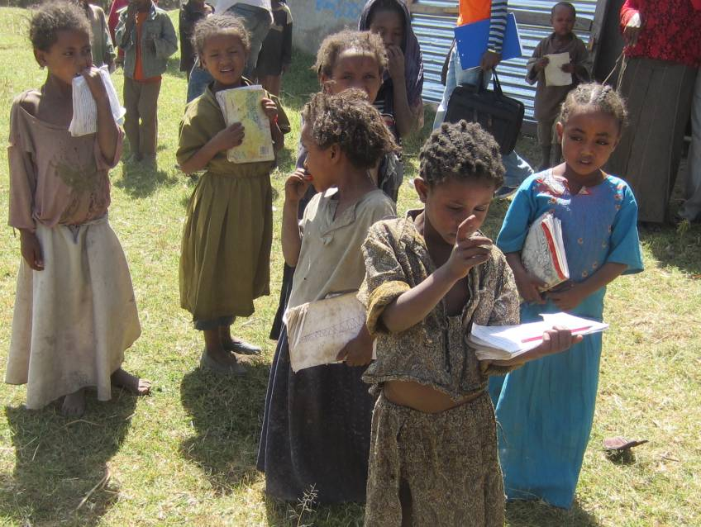

Drawing pictures and shapes with children - The situation of children drawing pictures/shapes with parents is very similar to reading. The majority of households acknowledged that no one draws with the children; only 9% do so in Siraro. This baseline survey did not assess the availability of drawing and art supplies (such as pencils, crayons, paper and paint) in the household, which could be a constraint. Like reading, drawing with children happened more often with the mothers and siblings than fathers.
Comment from the literature: Parents engaging in joint reading with their children are an important parental behaviour indicator of early childhood development and education interactions at home. Parents reading aloud to their children are an important prerequisite for early language development and stimulate the child in multiple ways. Parents engaging in play activities directly with their children support physical and cognitive development and this indicates of parental responsiveness.
Availability of books is also a requirement for the parents to engage in joint reading activity with their children.
The availability of toys, especially home-made toys created by adults and older siblings is also a good indicator of parental concern and sensitivity towards play as well as how they encourage children’s learning about exploration and problem solving (Iltus, S. 2007).
Parental engagement in play activities with children - Again mothers were more active than fathers in engaging the children for story-telling, singing and playing.

Table 34: Parents engage in early learning with children: read, draw, sing, storytelling & play
Parent engagement with children 0 to 5 years in past 7 days | Siraro
Overall number of activities children 0 to 5 years were engaged with an adult
- 0, no adult | 55%
- 1 | 20%
- 2 | 11%
- 3 | 9%
- 4 | 4%
- 5 | 1%
By specific activity | N=100
Read books to or look at picture books
- No one | 81%
- Mother | 6%
- Father | 2%
- Other | 11%, (brother, sister)
Drew shapes, pictures with children
- No one | 91%
- Mother | 3%
- Father | 2%
- Other | 4%, (brother)
Tell stories with children?
- No one | 71%
- Mother | 17%
- Father | 9%
- Other | 5%, (brother, sister)
Sing songs with children?
- No one | 70%
- Mother | 16%
- Father | 2%
- Other | 12%, (brother, sister)
Played with children
- No one | 60%
- Mother | 26%
- Father | 9%
- Other | 6%, (brother, sister)

7.3 Child care arrangements when caregiver is away
Sometimes adults (parents/caregivers) taking care of children have to leave the house to go to garden, the well, to market, to earn an income or for other reasons and have to leave young children (0 to 6 years) at home with or without a caregiver substitute.

This baseline asked about how many days in the previous 7 days children had 0 to 5 years been left under the following care arrangements:
- Left child alone for more than an hour?
- Left child in the care of another child, less than 10 years old, for more than an hour?
- Left child with other persons like Grandmother, Aunt, Housemaid, baby sitter, for more than an hour?
- Left child in the care of a neighbour, for more than an hour?
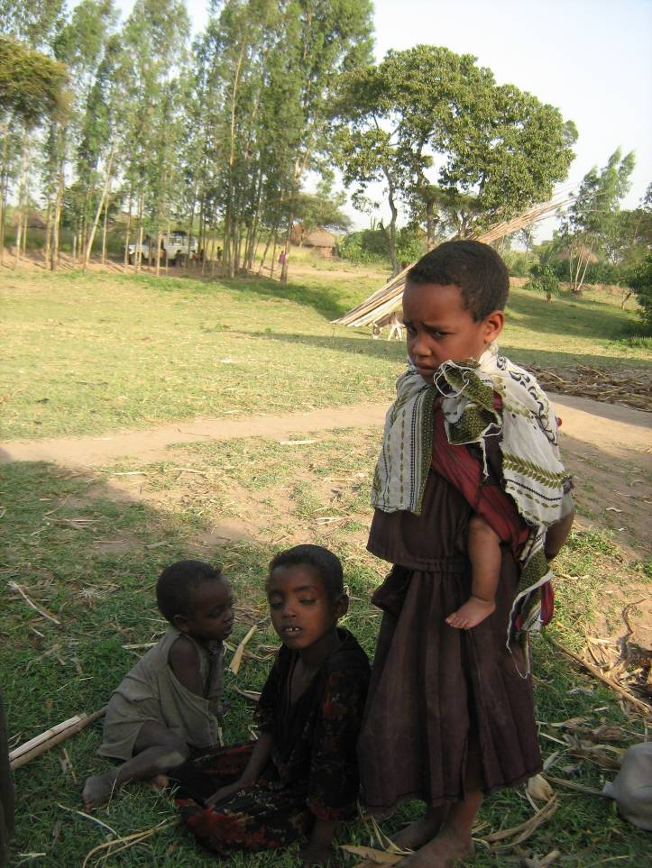
In Siraro, 50% of caregivers reported that they had had to leave children 0 to 5 years at home for any reason for at least one hour (in a 7 day recall period). When primary caregivers had to leave home, young children were more often left under the care of another child less than 10 years (37%). Other sources of substitute caregiver were relations like aunt, grandmother or babysitter/housemaid, 19%. Children were sometimes left with neighbours for caretaking though to a small extent, 15%.
Of concern is that beyond the 3 situations described above, this baseline revealed that in close to one-quarter (22%) of the households, children were left alone with no substitute caregiver.

Table 35: Child care arrangements when the caregiver has to leave children at home
Child care arrangements when the caregiver has to leave children 0 to 6 years at home | Siraro
 | N=100
In past 7 days were children 0 to 5 ever left at home without primary caregiver for at least 1 hour? Yes | 50%
Left in care of another child less than 10 years? Yes | 37%
Mean (number of days) | 0.8
Left with aunt, grandmother, Housemaid | 19%
Mean (number of days) | 0.3
Left alone for more than 1 hour? Yes | 22%
Mean (number of days) | 0.3
Left in care of a neighbour | 15%
Mean (number of days) | 0.2
Implication: Many children are left alone or with inadequate care, exposing them risk of physical injury, abuse or neglect. Such risks have been described in similar situations where inadequate care predisposed to injury, emotional abuse or neglect (UNICEF, 2012) Safer child care options will be needed at home when caregivers engage in CCCP promoted activities.

7.4 Attaining milestones - Attachment of infants to caregiver
Comment from the literature: A secure attachment to a trusted caregiver with consistent caring, support and affection early in life is essential for healthy early childhood developments. Securely attached infants and toddlers use their emotional and physical security as a base from which to explore their environment with successful attempts increasing the child’s self-confidence. Attachment, the affective bond of infant to parent, plays an important role in the regulation of stress in times of distress, anxiety or illness. Sensitive parenting causes secure infant attachment.

This survey explored about attachment of infants (children aged 6 to 24 months) to their care giver by asking about the infant’s reaction when he/she sees the caregiver and when the caregiver leaves the child. The emerging descriptions of the infant’s reaction were categorised into 3 patterns of attachment using the Strange Situation Procedure (Ainsworth et al 1978). The majority of infants in Siraro had a secure relationship to their caregivers.
Table 36: Development milestones for children 6 to 24 months old
 | Siraro
Reaction on seeing caregiver | (n=61)
Secure infant
1 = Smiles or his/her face lights up | 98%
2= Reaches for, crawls or runs to C-giver | 0
3=Calls out to come, see what s/he is doing | 0
Insecure ambivalent infant
4=Does NOT shows he/she is happy | 0
Insecure avoidant infant
5=Ignores care giver | 0
Others; 96=Other, unclear | 2%
Reaction on caregiver leaving | (n=61)
Secure infant
1=Cries/is unhappy a while, but settles down | 79%
In-secure ambivalent infant
2=Screams and cannot be comforted until caregiver returns | 15%
Insecure avoidant infant
3=Doesn’t notice even after saying bye | 2%
Others
4=Child never left alone or with others. | 2%
96=Other (specify) | 2%

7.5 Attaining milestones - Psycho-social development
To assess psychosocial development, this survey asked about growth and development for children 3.1 to 6 years in 5 of the following areas:
- Vision and fine motor - Child can pick up small things like stick or pencil with two fingers
- Hearing, language and concept development - Child can follow simple directions on how to do something correctly
- Social skills - Child usually get along well with other children
- Self-help skills, personal skills - Child dress him/herself
A large majority of children were reported to have developed psychosocial skills and for fine motor development, hearing and concept development, social skills and self- help skills.
Table 37: Psycho-social development for children 3 to 6 years old
 | Siraro
Psycho-social development for children 3.1 to 6 years olds | (n=93)
Fine motor development - Child can pick up small things like stick or pencil with two fingers | 98%
Hearing and concept development - Child can follow simple directions on how to do something correctly | 94%
Social skills - Child usually get along well with other children | 94%
Self-help skills - Child can dress him/herself | 81%
Psycho-social development for children 6.1 to 8 years olds | (n=30)
Hearing and concept development - Child can follow simple directions on how to do something correctly | 100%
Social skills - Child usually get along well with other children | 100%

7.6 Opportunities to improve parenting - parent education
Some community sensitizations have been taking place on the importance of ECD education, child care, health related topics like family planning. Kebele leaders said that currently there were no community trainings on parenting skills, e.g., on engagement and stimulation of children.

The household survey asked about parent training and parents’ sources of information on a number of areas including: hygiene, health care, nutrition, how to help a child develop and ways to discipline a child.
In general parent education through sensitisation or other sources of information is limited. Parent sensitisation/training was on the low side – 58% in hygiene and sanitation, 54% on nutrition and feeding of children, 49% how to help a child develop and 43% on ways to discipline a child.
Radio was the commonest source of information but only a few households had used it as a source of information – 24% in hygiene and sanitation, 20% on nutrition and feeding of children, 18% how to help a child develop and 12% on ways to discipline a child.
Table 38: Parent training and sources of information on child care
Any household member received teaching on any of the following | Siraro
Activity | N=100
Hygiene / cleanliness, Health care
- No one | 43%
- Mother | 47%
- Father | 11%
Nutrition, feeding of children?
- No one | 45%
- Mother | 49%
- Father | 6%
How to help a child develop
- No one | 51%
- Mother | 43%
- Father | 6%
Ways to discipline a child ?
- No one | 57%
- Mother | 39%
- Father | 4%
Household source of information on the following topics | Siraro
Topic | N=100
Hygiene / cleanliness, Health care
- No one | 76%
- Radio | 24%
- TV | 0
Nutrition, feeding of children?
- No one | 80%
- Radio | 20%
- TV | 0
How to help a child develop
- No one | 82%
- Radio | 18%
- TV | 0
Ways to discipline a child ?
- No one | 88%
- Radio | 12%
- TV | 0

Enrolment and attendance of ECD
This baseline survey explored enrolment and attendance from households, from ECD and Grade 1 facilities and from local leaders. From the village profile, some ECD facilities exist in communities that have a primary school with a ‘zero class’. In addition there are two ECD centres in Ropi 01 and Alemtena sirbo supported by the SCFDA and funded by ChildFund.
Comment from the literature: A variety of early learning programmes are found worldwide, including those offered through community-based centres, day care facilities, kindergartens and preschools. These programmes may be organized by the state, private institutions or a variety of community-based organizations, including religious groups. Early childhood care and education of good quality can benefit not only young children, but also mothers and other caregivers, whose time is freed up for educational or vocational activities, and society at large (UNICEF 2012, Inequalities in ECD).

8.1 ECD enrolment

ECD enrolment
Children targeted for enrolment - Within the CCCP operational area, there are six zero classes and two ECD centres for early childhood development and education. All the ECD facilities enrol male and female children in the age range of 3 to 7 years old. Some ECD facilities, however, have children older than 7 years. The two ChildFund supported ECD centres specifically mentioned targeting children with disabilities, orphans and children from very poor households. Alemtena ECD centre gives priority to children from mobile community members.

Community mobilisation for ECD facility enrolment – Is done by multiple agencies, for example, Woreda Education Office, PTAs, kebele leaders and ECD/Zero Class centres. All of these groups sensitise and mobilise parents to send their young children to ECD/Zero Class centres. Mobilisation activities are conducted through home to home visits and community meetings, and talking to parents by calling them to the ECD/Zero Class centres. SCFDA mobilises specifically for the two ECD centres it supports.

Selection of children for ECD/Zero class centres - In most of the facilities, enrolment is open other than a lower age limit of 4 years as the only criteria. Uniquely, Hude Gudina Zero Class Centre in Ropi 01 Kebele gives a short screening quiz to the children to check their ability to listen and speak at the times of registration.

Under-enrolled children for ECD - Despite this open policy to enrolment, some categories of children find it difficult to enrol: for example, children that are not covered by the sponsorship programme Ropi ECD in Ropi 01Kebele; children with disability; children suffering from malnutrition and those who have no clothes or materials to use for school; children from very poor households; from mobile households, i.e., parents moving from place to place in search of livelihoods; and children living in distant/remote areas.

Often disable children are excluded from ECD system because the centres are far away from residential areas and brail teachers are not available for children with hearing difficulty. Proper data is not obtained from the zero classes and ECD centres on number of children with disability living in the areas. However, the reports from these centres indicate no child with disability is attending zero classes.

8.2 ECD attendance for children 3 to 6 years

Past child participation in early childhood education programs
To assess past attendance of early childhood care and education, this survey asked if children 6 to 8 years old who are currently in primary school had ever attended any ECD/pre-school facility. The reported past ECD experience for children 6 to 8 years in primary schools was 33% in Siraro. Children’s periods of attendance at an ECD facility ranged from 6 months to 3 years.

Current child participation in early childhood education programs
The survey then asked if children 3.1 to 6 years of age who were present in the household at the time of the survey were currently engaged in any early childhood care and education arrangements outside the home. The proportion of children 3 to 6 years currently engaged in any kind of early childhood care and education arrangement was 30% in Siraro. Of these, 11% of the children were in NGO supported/led ECD centres (which included ChildFund supported ECD facilities). A small proportion of children 3 to 6 years (10%) had already joined primary school. Anecdotal information gathered to investigate this premature primary school entry was that the child was eager to go to school yet there were no nearby age-appropriate early childhood care or education facilities, so parents enrolled the children in Primary school.
Other alternative arrangements for early care, e.g., mobile, home-based or neighbourhood based were not mentioned among the options for early childhood care and education in the programme area.

In Ethiopia, Government has introduced an innovation whereby almost all government schools (44/45) in the CCCP programme area (## out of ## government primary schools) include a “zero class”. About 1 in 10 (9%) of children in 3 to 6 years in Siraro were in such a ‘zero class’.
Question - What content/curriculum/activities in the zero class? How closely does it parallel curriculum in SCFDA managed ECD centres?
By gender – In Siraro, female children 3 to 6 years were less likely to be enrolled in any early childhood care and education facility.

On trends, attendance of ECD has not changed much between children currently in grade 1 (6 to 8 years olds) and those 3 to 6 years. Only 33% of children (6 to 8 years old) in primary attended any form of ECD
Table 39: Child participation in early childhood care and education arrangements
Enrolment status - CURRENT early care and education experience for 3 to 6 year olds | Siraro - All | Siraro Males | Siraro Females
Where is the child currently enrolled | N=93 | N=44 | N=49
0 = No where | 70% | 68% | 73%
1 = ECD centre NGO funded/led; Community child care Centre | 11% | 14% | 6%
4 = Private Nursery/Kindergarten | 0 | 0 | 0
7 = Primary school | 10% | 7% | 12%
8 = Zero class | 9% | 11% | 6%
96 – Other not clear, not specific | 0 | 0 | 0
MAIN reason why child 3 to 6yrs is not enrolled anywhere? | N=62*** | Rank
1 = Child still young to start school | 82% | 1st ^{t}
2 = School far, No school nearby | 11% | 2nd
4 = Unsafe for child, | 0
5 = Expensive, no money for fees, school supplies, etc. | 0
96 = Other, unclear, un specified | 7%
98 = Don’t know | 0
PAST ECD experience 6 to 8 year olds | Siraro - All
Children 6 to 8 in primary sch attended any ECD facility? | N=18
Yes | 6/18, 33%
For How long? | N=6
0.5 year | -
1 year | 4/6, 67%
2 years | 2/6, 33%
****Siraro no information on why 3 children not enrolled

Why children 3 to 6 years are not currently enrolled at an ECD facility/school
A range of reasons were presented by parents/caregivers of non-enrolment of children 3 to 6 years. The leading reason was that the 3 to 6 year old child is too young to start school. School being far/no school in the vicinity is the second most common explanation. This reason is actually closely linked to the first reason about child being too young because almost all the children had to walk to school (see section 9 on access to ECD and primary school). Children that were mature enough to walk the distance were more likely to attend school. So access and proximity to and ECD facility are among the leading reasons.

Attendance reported at ECD facilities
At the time of this baseline survey (2012) about 594 children were attending at the eight ECD/Zero Class centres in the CCCP operational area. Slightly over half (55%) of these children were boys; the remainder (45%) were girls. About four-fifths (80%) of children attending ECD/Zero Class centres were in the age range of 3 to 5.9 years. One-fifth (20%) of the children were six and above years old. ECD facilities were not consistent in recording number of vulnerable children, so there is no accurate information on the proportion of children with disabilities or orphaned children among those enrolled.

Days and hours of operation – almost all (7 out of 8) facilities were open five days per week (Monday to Friday) but in Damine Olana the children and the caretakers stay together in the centre only for three days (Tuesday, Wednesday and Thursday), but the reason was not specified. The children are at the ECD facilities usually from 7:30 to 10:30hrs, i.e., for a good part of the morning each day. Only two of the eight centres had a visible weekly timetable and daily routine showing activities from arrival up to farewell.

Activities/programme - Most of the centres do not have a uniform daily routine or a weekly time table format. Where it existed, the teachers/caretakers said they had initiated it and developed it on their own. It was not clear to the survey team if there is a standard ECD curriculum (national or regional) being followed in the ECD centres and zero classes.

Daily registration for children - Taking students' attendance on daily basis is an important aspect of ECD/Zero Class centres. From the eight EDC/Zero Class centres in the programme area, only four of them are keeping a register book. The remaining four have no register books because they started the ECD/Zero Class centres very recently and have no pre-set attendance sheet prepared for this purpose. In addition, only three ECD/Zero Class centres consistently marked children's attendance in the last 10 school days prior to the survey.

Data was obtained from two Zero Class centres (including Hunde Gudina and Damine Dhiha) for the five school days preceding the survey. The two graphics below show that the numbers of children who attended the two centres in days before the survey by location of centres and gender. As indicated here, the number of children attending the EDC/Zero Class centres in Hunde Gudina ranges from 45 to 65 and from 35 to 46 in Damine Dhiha. These data show that attendance of children at the centres is irregular. For instance, on one of the days, about 28% of children were reported absent.

Figure 1: Number of children attended Zero Class centres in the last five days by location | Figure 2: Number of children attended Zero Class centres in the last five days by gender

Some of the ECD/Zero Class centres indicated the reasons why children are absent from their classes. The most common reasons mentioned during this assessment were: market days, child sickness, harvest time, or migration of households in search of food and water. Some of the other reasons include parents who get tired of bringing their children to the centres on daily basis, food shortages, children required to attend to some domestic work and keep house, or no proper follow-up by parents and teachers.

8.3 Children’s school readiness

Eagerness and regularity of school attendance for 3 to 6 year olds in school
A large majority of children 3 to 6 years in ECD/zero class are eager to attend school (96% in Siraro). School attendance was high for the 3 to 6 year old children enrolled in ECD, the majority of whom had attended all of the past 5 school days preceding the survey (84% in Siraro).
Table 40: Children’s readiness: eagerness and regularity of attendance
Eagerness to attend school and attendance (using most recent 5 school days) for 3 to 6 years | Siraro
If child is enrolled in ECD or primary, is the child eager to attend school? | N=28
Yes | 96%,27/28
No | 4%,1/28
If enrolled in school how many days in past 5 days did the child attend school? | N=26
0 | 4%
1 | 0
2 | 4%
3 | 4%
4 | 4%
5 | 84%

Other signs of school readiness
Nutritional status - Some of the children 3 to 6 years were malnourished, 21% under-weight, 52% of them stunted, and this is bound to interfere with their school attendance.
Developmental milestones - See also section 7.5 on developmental milestones for 3 to 6 year olds for fine motor, psycho-social development for 3 to 6 year olds.

8.4 Primary school enrolment
Responses from KIs with Kebele leaders - The mobilization process for enrolment in grade 1 is through awareness raising sessions by teachers, school directors and community leaders urging the community to send their children to school. Out of the eight teachers interviewed, four teachers had done community sensitization on enrolment in primary school.
According to KI respondents in schools, all children that have attained the minimum age of 6 to 7 years are eligible to enrol for grade 1. All children regardless of their physical condition and parental economic conditions are targeted. However, in one school (Damine Olana) prospective students are required to pass an exam organised by the school.

Under-enrolled children for primary school - While no children are discouraged, children that are physically fit (able to walk to and from school) and live in closer communities were more likely to enrol. Teachers also noted that children from households with lower economic capacities. Some households do not want to invest in buying school materials for children due to low awareness on the importance of education. Also some children who are considered ‘old enough’ to take care of cattle or engage economic activities that earn income, so they did not attend school (i.e., child labour).

Children with disabilities were less likely to enrol. Furthermore, children with severe disabilities like blindness do not go out of home because parents fear of stigma and the school environment is not favourable/adapted for them to attend. Severe disability would require an adult family member to get such a child to and from school and as most parents are busily engaged in livelihood activities, this would be a distraction from economic opportunities.

None of the teachers in ECD or grade 1 were trained in special learning needs for students with physical or learning disabilities. Schools/teachers have no skills and tools to detect children with learning difficulties and how to support such children.

Primary school enrolment for children 6 to 8 years (from the households)
Enrolment for 6 to 8 year olds quite modest in Siraro; the proportion of children 6 to 8 years engaged in any kind of schooling were 70% in Siraro. The majority of these children were in primary school (60%), though a small proportion (10%) were still attending pre-primary level (ECD centre/zero class). A greater concern, however, is the proportion of 6 to 8 years that have not started school (30% in Siraro).

Reasons for 6 to 8 year olds not enrolling - Similar to the 3 to 6 year age group, the perception by parents/ caregivers that the child is still too young to start school was common in Siraro. Female children aged 6 to 8 years were less likely than males to be enrolled in school. Cautious interpretation is needed, however, because of the small numbers.
Table 41: Enrolment of children 6 to 8 years
 | All | ET - All | ET - Ma | ET - Fe
School enrolment for 6 to 8 year olds
Where is the child currently enrolled |  | N=30 | N=12 | N=18
0 = No where |  | 30% | 17% | 39%
2 = Primary school |  | 60% | 75% | 50%
1 = ECD or Nursery |  | 7% | 8% | 6%
3 = Zero class |  | 3% | 0 | 6%
Why child 6 to 8 years old is not enrolled anywhere? |  | (n=9) | Rank
1 = Child still young to start sch |  | 4/9, 44% | 1st
2 = School far, No school near |  | 3/9, 33% | 2nd
5 = Expensive, no money for fees, supplies |  | 1/9, 11%
96 = Other, unclear |  | 1/9, 11%

8.5 Primary school attendance

Attendance as reported by kebele teachers
The majority of primary schools (6/8) had registers to mark students’ daily attendance (Awarkasa, Hunde Gudina, Biftu Siraro, Sirbo Gebeta, Damine Dhiha and Damine Olana). However, only 3/8 schools had marked children’s daily attendance for the past 10 school days and only 4/8 had attendance marked on the day of the survey. Teachers complained about heavy burden of work and limitations of time to track the daily recordings. At the time of the survey, non-universal availability of records coupled with irregular use of attendance recording makes it difficult to assess the regularity of pupil attendance from school records.

Qualitatively G1 teachers observed that children sometimes miss school for a number of reasons including, e.g., illness, household problems like food shortage and hunger and demands for doing household chores. During market days (held weekly), school attendance is also lower as children are obliged to stay at home taking care of domestic activities and keeping household properties while parents went to market.

Eagerness and regularity of school attendance for 6 to 8 year olds in school
A large majority (95%) of children 6 to 8 years that were in school were eager to keep on attending school. School attendance was high for the 6 to 8 year old children in school, and the majority of them (86%) had attended all the past 5 school days preceding the survey.
Table 42: Eagerness to attend school and frequency of attendance for 6 to 8 year olds
Eagerness to attend school and attendance (using most recent 5 school days) for 6 to 8 year olds | All | Siraro
If child is enrolled in ECD or primary, is the child eager to attend school? |  | N=21
Yes |  | 95%,20/21
Sometimes |  | 5%,1/21
For enrolled – Number of day in past 5 days did the child attend school? |  | N=21
0 |  | 0
1 |  | 5%
2 |  | 0
3 |  | 0
4 |  | 9%
5 |  | 86%

Access to ECD facilities and primary schools

9.1 Accessing ECD care and education facility

Physical distance (estimated) from home to ECD facility
Households were situated varying distances from any facilities offering early childhood care and education. Respondents estimated the distance from their homes to the nearest facility offering early childhood care and education and the one attended by any children 0 to 6 years in the household. The median distance to the nearest ECD facility (i.e., for the 50% of households who gave specific distances) was 1km in Siraro. Households reporting that they had children attending ECD had shorter distances to the ECD facility than the overall survey sample. The median distance to the nearest ECD facility attended (i.e., for the 50% of households that gave specific distances) was 0.5km.

How ECD level children get to and from school
Travel means to and from ECD facility - All children attending ECD were walking to and from their ECD facility (100% Siraro). Home owned means of travel, or hired private means (bicycle, motor bike) or public means of travel did not feature among the travel options (probably due to cost and non-availability).

Who takes ECD level children to and from school - the ECD level children in school commonly went to school alone (39%), with siblings/with other children in the neighbourhood (61%). The same pattern is seen when children return home from school. Adult (including parental) involvement in taking ECD level children to and from school is very low (0 in Siraro).
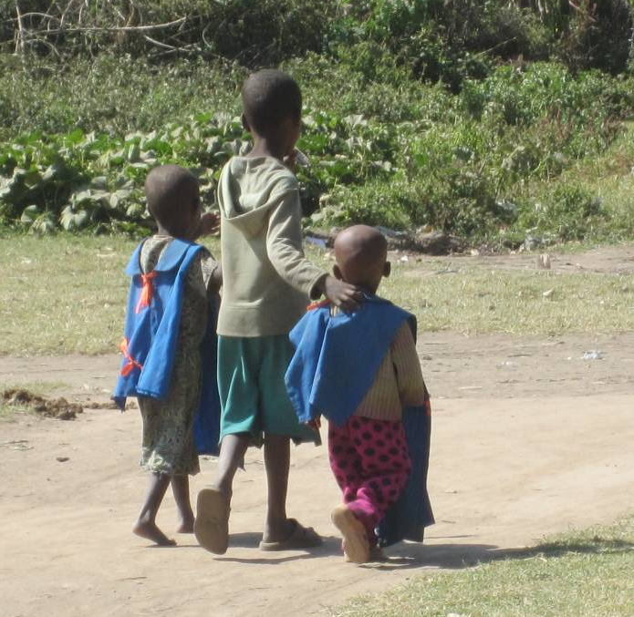
The above access pattern of long distance to ECD facility (relative to child’s age) and walking to school with limited adult support on the way to and from school could partly explain why the commonest reason for children 3 to 8 years not going to school was “the child is still young”. Children started school when they were considered mature enough to walk the distance to and from the education facility.
Table 43: Access to ECD facility – distance, travel means and parental support
 | Siraro
ECD facility access | (n=100)
Estimated distance from household to NEAREST ECD facility – ECD, Zero class in Km
Up to 0.5Km | 24%, 24/100
0.6 to 1km | 14%, 14/100
Over 1 km | 24%, 24/100
99 – No ECD facility in the village, so no estimates given | 38%
 | (n=62)*
Mean (in Km) | 1.4
Median (in Km) | 1
Range (in Km) | 0.05 to 5
ECD facility access | Siraro
Estimated distance from household to ECD facility ATTENDED – ECD, , Zero class in Km | (n=17)**
Up to 0.5Km | 50%,9/18
0.6 to 1km | 17%,3/18
Over 1 km | 33%,6/18
 | (n=17)**
Mean (in Km) | 1.02
Median (in Km) | 0.5
Range (in Km) | 0.1 to 3.5
Time taken from home to ECD facility | (n=17)*
Mean (in hours) | 0.6
Median (in hours) | 0.5
Range (in hours) | 0.2 to 1.5
Travel means to and from ECD facility attended
Travel means commonly used to and from home to ECD facility | (n=18)**
- Walk to school | 100%
- Taken by home bicycle, Hired motorbike, bicycle, Bajaj; Public means, School bus, Horse, Donkey cart | 0
Who takes ECD level children to and from school? | (n=18)**
Who commonly TAKES children to ECD facility?
- Alone | 39%
- With other children, Siblings | 61%
- Mother, Father, House help, other relative | 0
Who commonly RETURNS children from ECD facility? | (n=18)**
- Alone | 39%
- With other children, Siblings | 61%
- Mother, Father, House help, other relative | 0
** Households with children attending ECD facility and reporting

9.2 Costs of care and education for children in ECD facilities
This survey asked about (estimated) monetary and non-monetary costs for educational services being covered by households with children enrolled in an ECD facility since January 2012.

Monetary costs - The survey asked about direct monetary costs made by parents/caregivers to ECD facility, for example, money to cover fees for school, uniforms for child, ECD caretaker salary, for construction, for transport. Costs are very low and rare in Siraro; only two households reported monetary contributions for fees equivalent to US$1.4.

Non-monetary costs - The survey asked about non-monetary costs that households with children in ECD facility have made since January 2012; but this was virtually a non-existent factor in Siraro.
Table 44: Monetary and non-monetary costs for households with children in ECD
Monetary - Costs for children in ECD | Siraro
Estimated costs paid by households to ECD facility, in US$ equivalent | N=18*
- Fees paid for children in ECD | Paid - 2/18; Amt - 1.4$
- Uniform bought for children in ECD | None or no cost
- Contribution towards ECD caretaker salary | None or no cost
- Contribution towards Construction of ECD | None or no cost
- Costs towards ECD Transport | None or no cost
- Costs towards ECD instruction materials | None or no cost
- Contribution towards Food at ECD facility | Paid - 1/18; Amt - 1$
Non-monetary - Costs for children in ECD | Siraro
Type of non-monetary contribution made | N=18*
- Contributed food to ECD facility | None or not counted
- Contributed time, meeting at ECD | Yes - 1/18
- Contributed labour to ECD facility | Yes - 1/18
- Token for ECD caretaker | None or not counted
- Other non-monetary items, contributions | None or not counted

9.3 Parent participation both ECD and Grade 1
Active parental participation at home and at school supports children’s readiness for and transition to primary school. In this survey parent participation was assessed in in varied ways: financial contribution, in-kind support in a form of labour, construction material, land, etc. and, allocating time to assist schools attending parent-teacher meetings at schools.

In general parent participation in school activities is low, both in ECD centres and primary schools. For example, for the 8 primary schools in this survey 5/8 reported some financial contribution and 2/8 in-kind supports like labour, plough oxen and other materials for the school farm. None of the schools mentioned time or labour contributions to assist the schools
Opportunities for parent engagement are also limited, only 5/8 primary schools reported regular parent-teacher meetings. Out of 8 zero classes/ECD centres, 4 centres, namely: Awarkasa, Boye, Ropi Sinta and Hunde Gudina, have been reported to have parent-teacher meetings for which all have evidences/minutes to do so.
The household component of the survey also shows low financial and non-financial contribution from households. Only 2/18 households with children in ECD had paid fees, only 1/18 had ever attended meeting and 1/18 given labour to the ECD centre/zero class.

ECD and education services

10.1 ECD in Siraro: status, facilities, availability & access

Status of ECD in Siraro district:
The survey team interviewed teachers/caretakers responsible for zero class teachers and ECD centres and made observations in the same facilities. Interviews with leaders in the five kebeles shows that ECD education activities only recently started in Siraro district, the quality of present ECD is generally low and there are a number of constraints with the present services.

Meanwhile, even though ECD education is new, some kebele leaders were already reporting they have seen differences in the children that attended ECD compared to the children who did not attend, “…they are more active in their social interaction and able to transfer to the next level easier.”

Current records from Siraro district indicate that there are 46 institutions providing pre-school activities. Of these 2 are ECD centres funded by ChildFund and managed by Siraro children and family development association (SCFDA) (with 80 children enrolled, 34 males and 46 females). The majority of pre-school facilities (44/46) are zero classes in government owned primary schools; with 2809 children enrolled (1573 males and 1236 female) (Source: Siraro District Education office, 2012).

The presence of the ‘zero’ classes in primary schools is an opportunity to provide ECD education for more children.

Coverage of ECD education services
There is limited coverage and inequitable distribution of ECD education facilities. Some kebeles like Boye Awarkasa have no ECD centre (only zero class); while in Alemtena, only one zone 1 (the town, out of three) has an ECD centre constructed by SCFDA. Even the available ECD facilities have a limited number of vacancies, thus leaving out many interested children. In fact the two ChildFund supported ECD centres are currently full, as they are stricter on number and age categories of children admitted. However, in places like Ropi 01, the capacity of the ECD centre had been exceeded by the demand; number of children wanting to join the centre is more than the capacity of the centre.

“The bad thing is that ECD centre is available in only one out of three zones in Alemtena. For some children the centre is too far to attend; only the Alemtena town children are attending. Children from other zones are facing problems of getting to the ECD centre and primary school; the topography is difficult. Kebele respondent, Alemtena

There are 9 ECD facilities in the CCCP programme area, 7 zero classes and 2 ECD centres. There is no home based/neighbourhood or mobile ECD education type in the survey areas. Most of the ECD facilities (except 1) were recently established (between 4 months and 7 years). Except the ECD centre in Ropi 01, the rest of the facilities are owned by government. Ropi ECD centre is owned and managed by NGO (SCFDA).

Monitoring and supervision – The schools reported that district education staff regularly (twice in a month) supervise zero classes in government schools while the SCFDA supervises the NGO funded ECD centres.

From the survey it is unclear if the two SCFDA managed ECD centres have had any formal registration processes with the kebele or Woreda (or if they are expected to). The SCFDA managed ECD centre has not been registered by district education department.

Implication: The need for registration/formalisation will have to be clarified if more NGO or private ECD providers come to Siraro, and are seen to be competing with the government zero class system.

Resources, Support and Funding for ECD education facilities
Government supplies educational materials including books and supports teachers in zero classes. Only a few ECD services were reportedly by NGOs, for example, SCFDA support food provision and meet health costs for children enrolled in sponsorship program.
Kebele budgets and expenditure for ECD – Leaders acknowledged that ECD education is a new area with no specific plans or budgets yet. The leaders in all the 5 kebeles visited for this survey said that they have no plans or budget/expenditure specific for ECD education (Boye Awarkasa was starting). In fact, the kebele leaders are not aware of the budgets/expenditures of the ECD facilities (government owned or the SCFDA managed) in their localities.

ECD learning and play materials are limited for children as well as teachers. Present attempts by district and lower local government to support and mobilise for ECD education are hampered by lack of awareness of locally appropriate ECD education materials. Leaders were not aware of the ECD education related policy documents, guidelines and plans for national, regional or district level.

Current kebele support for ECD education activities
The most common current ECD education support activities were were mobilizing parents to send children to ECD ,identification and provision of land for ECD centres and schools, e.g., in Boye Awarkasa, Alemtena provided one site and 2 more potential sites were identified. Kebele leaders said they, e.g., in Boye Awarkasa, Leman, Alemtena.

At the time of the survey kebele leaders did not foresee financial support towards ECD education in the near future, though they pledged to support efforts to acquire land for ECD, to collaborate with NGOs offering ECD education (like SCFDA).

ECD centre management committee
Existence management committees - Among the strategies of the CCCP is to have “functional” management committees in the planned ECD centres, i.e., holding regular meetings, having a constitution, etc. Only three of the 8 ECD facilities surveyed (Awarkasa, Boye and Damine Dhiha) reportedly had centre management committees with a predefined schedule and regular meetings (Awarkasa School failed to mention its meeting schedule during data collection). Note that for zero classes, these are committees for the whole school and not specifically for zero class.

Benefits of having management committee - Almost all schools that have the management committee have noted the benefit of having the committee as a means to mobilize community and children towards ECD/zero class enrolment and attendance, identify specific problems, propose solutions and submit reports to school board.

Constitution - Only 1 out of the 8 centres (Boye management committee) reported having a constitution or by-laws that define scope of work, roles and responsibilities of the management committee and schedule of the management committee meetings.

10.2 Linkages between ECD facilities and other structures
The survey explored to what extent ECD facilities link and associate with other institutions for example - primary schools, health units, local leadership at kebele and villages, district departments of education, health and child protection In general, except for zero classes that are in the same compound as the primary school, linkages are only beginning to develop.

Primary schools - The ECD centres and zero classes have strong linkages with primary schools since zero classes are in the compound of primary schools and under the management of primary schools. Zero class teachers send the lists of students to the grade one teacher at the beginning of the academic year. The monitoring and support is handled by the school administration/ supervision and assigning teachers and provision of teaching materials to zero class are provided by the school administrations. Zero classes are in the primary school compound while Ropi-01 and Alemtena ECD centres are within 2km of the nearest primary school.

Health units - Most of the ECD centres (5 out of 8) in the survey area have linkages with nearby health units. Health units support ECD children in providing immunization and treatment when injuries are reported. None of the health units had done any screening exercises in the schools.

Local leadership - Regarding linkages between ECD centres and village leadership, there are village leaders who are members of the school management committees and they mostly mobilize communities to send their children to ECD centres. Kebele support to ECD centres are represented by village administrators and not directly by kebele leaders; ECD centres/zero classes do not have direct links with kebele leadership.

District departments – The zero classes in government primary schools are under the district education department – so as part of the schools they get supervision and technical support, resources, materials and supplies. Linkages of primary schools (and zero classes) to other district departments like health, child protection units are not as regular as with education. The NGOs supported ECD centres do not appear to have any formal linkages to the education department or any other district departments.

Human resources for ECD education, ECD facility teachers/caretakers
ECD education human resources are limited both in numbers and skills training.
Pupils per teacher – On average there are 72 children under the management of one teacher with no assistance. This represents a lower level of support or coverage for the pupils than the recommended standard of 40 children per teacher in Ethiopia (citation).

Recruitment and qualifications - ECD/zero class teachers/caretakers were recruited by government, the community and NGO (SCFDA) on competitive basis. Caretakers are between 20 and 35 years of age (86% of the caretakers were below 30 years) and about half of them (53%) were female.
Basic education level of the caretakers varied from 9th grade to diploma (2, 9th grade; 4, 10th grade and 8 beyond 10th grade). Only 2 of the 14 ECD teachers had ECD training and only 4/14 had short courses in the past 1 year on varied topics including - child care, nutrition and psychosocial support.
Kebele leaders, in Boye Awarkasa said of the 14 teachers (in ECD and) only in 4 (all males) have got training in ECD education.

Establishing the zero class in each primary school is government’s strategy to access to increase access to ECD education. However, it is hampered by shortage of budget/funds. In some schools the same teacher was responsible for zero class and G1 class, as schools lacked additions funds to hire zero class teachers.
Zero class/ECD centre teachers’ attendance - The study revealed that most of the ECD teachers were present on the day of the survey. There is a register in which to mark daily presence of the teachers/caretakers. However, it has been learnt that the attendance is not regular and does not capture all the required information, for example reasons for non-attendance.

Teacher attendance is generally high (only 2 of the 8 facilities showed that a teacher was absent during the most recent 5 days). Occasionally teachers do not come to schools due to when sickness, funeral of the relatives, trainings/workshops. Some do not have regular payment or incentive and so they are not regular, for example, in Damine Olana.

10.3 Physical environment of the ECD facility classrooms
Kebele leaders were frank that the majority of present ECD facilities do not meet the national standards, e.g., regarding caretakers, teaching materials, equipment, infrastructure, safety. While supervision is currently undertaken by ECD committee and woreda education office they mostly focus on controlling enrolment and monitoring attendance.

There is no adequate ECD centre child that is sufficient for the large number of children in this kebele (Ropi 01). The existing ones including the CF supported still lack a number of necessary equipment.

A physical assessment was done of 8 ECD facilities (2 ECD centres Ropi and Alemtena managed by SCFDA) and zero class classrooms in 6 primary schools (Hunde Gudina, Awarkasa, Boye, Ropi Sinta, Damine Olana and Damine Dhiha managed by government).

Standards used - As per Ethiopia national standards and ChildFund Ethiopia ECD minimum standards, each child in ECD facility must have enough space to move about freely. There must be at least 1.5 square meters of indoor and 2 square meters of outdoor playing space per child; and no more than 40 young children per one teacher; and at least one caretaker in one class.

Indoor space - This baseline assessment of ECD facilities shows the average sizes of the rooms are 52 square meters and average number of pupils is 72, giving 0.72 square meters per child. This is only half of the space per child mandated by the minimum standards for Ethiopia and ChildFund Ethiopia (which is 1.5 square meters per child).

Class room structure - In two of the schools Ropi Sinta and Damine Olana primary schools, there was no structure; the zero class was organized and managed under a shady tree on the school compound. For the other 6 ECD classes, the roof types varied; 4 had iron sheet roofing and 2 were grass thatch. The walls were semi-permanent for 4 (made of mud) and permanent for only 2 (made of blocks/bricks). Five of the six classrooms had cemented floors. On safety, five of the 8 are in a fenced environment and all have gate at the entrance to control children movement.

Walls - Only 3 of the classes had painted walls (Hunde Gudina, Ropi ECD centre, and Damine Dhiha). None of the classrooms in all the schools had pictures, charts or and children’s work displayed on the walls. The classroom environment like the painting of the class, having various pictures/drawings on the wall and displaying children’s works could have added value to attract and hold their attention while in class.

Lighting and ventilation - As per the classroom standard, a room must have adequate lighting as well as ventilation. In this survey, 4/8, 50% of the classrooms (Hunde Gudina, Ropi ECD centre, Boye, and Damine Dhiha) were well ventilated and 3/8 had adequate lighting.

Furniture and sitting - The sitting arrangement for the zero classes was the same as the other primary school students, i.e., sitting in regimented rows facing the blackboard. While in Ropi and Alemtena ECD centres children sat in circles on mats.

Indoor and outdoor learning and play materials and equipment – According to Ethiopia ECD standards (citation ) ECD centre and Zero classes need to be furnished with locally made and appropriate indoor and outdoor playing equipment that are developmentally appropriate for the number of children in a protected and secured space of the premises. The equipment must be checked periodically and repaired as needed and must be clean and safe for young children.
According to this survey, none of the zero classes and ECD centres had teaching materials like puzzles, toys, children’s books, and charts. Both ECD centres in Ropi and Alemtena have space for outdoor playing and have some play equipment like swings and tires but lack indoor games.
SCFDA have provided outdoor playing material as well as meals for children in the 2 SCFDA supported ECD centres.

Water, Sanitation and Hygiene at ECD facilities
Drinking water - The ECD centres and zero classes do not specifically provide drinking water for children while at school. There is water in the school compound used for different general purpose like cleaning. Only 2 of the 8 centres (Ropi ECD centre and Boye Primary school) were using safe water; piped water from public tap about 100meter out of school compound. Three out of 8 schools (Damine Dhiha, Damine Olana and Ropi Sinta) were using unsafe surface water sources (ponds). In 3 schools water used was carried from home by the children. None of the zero classes provides meals for children, all children are expected to eat at home.

Latrines - Only four out of the eight ECD facilities (Awarkasa, Damine Dhiha zero classes, Alemtena and Ropi ECD centres) had latrines for children to use while at school. All the four were improved latrines, with concrete slab, with some adapting the hole size to suit young children at this school age. However, none of the latrines had hand washing facilities – container, water or soap!

Implication: There is an opportunity to use tippy taps (appropriate technology hand washing units) at ChildFund ECD centres and then promote them widely for all primary school facilities.

Rubbish disposal means is generally poor. Only 3 of the 8 ECD facilities had garbage disposal locations, while the majority 5/8 of the schools (Awarkasa, Ropi ECD centre, Boye, Alemtena ECD centre, and Damine Olana) had no specific garbage for disposal locations.

First aid kit – Four out of the eight centres (Boye, Sinta, Damine Dhiha and Ropi Siraro) reported having first aid kit. However, only one out of the eight had caretakers with first aid training.
Similarly, other facilities that could be used for teaching and learning are rare – 3/8 had radios but none had facilities like television, video, camera, electricity, phone, computer and internet.

10.4 Primary schools and their readiness for children

Readiness and transition for school

School’s readiness for children
Comment from the literature: School readiness and transition are closely linked. ‘Transition’ describes the period of time before, during and after a child’s move into primary school, either from home or from an early childhood programme. Starting primary school is a momentous and sometimes stressful experience for most children and an indelible memory for most people. A positive transition experience is possible. For a smooth transition, children must be ready for school; schools must also be ready for the children and parents must be ready to be involved and supportive before and after children start school.

For a school to be ‘ready’ for children, it must be an environment in which all children are able to learn, where staff members are welcoming and appreciative of children’s efforts, ensure their safety and sense of security and provide effective learning opportunities which enable children to interact effectively with their world. Often children joining primary school come in at different levels of readiness and schools have to be ready for each child and to offer them a supportive environment that enables them to blossom and learn effectively.
Comment from the literature: While the international early childhood education is 0 to 8 years, the 6 to 8-year-olds and their transition to primary school has received less attention relative to the 0 to 3 and 3 to 6 year age groups. ECD education needs to be better integrated in early primary education. (Arnold, C et al, 2007 and Britto, et al. al., 2006)

Status of the Grade 1 class
There are a total of 45 primary school in Siraro all owned by government with a total of 29,511 children; 17,739 male and 11,772 female (Siraro District records, 2012). To assess primary school readiness the survey visited all the 8 primary located in the 5 kebeles covered by CCCP and interviewed the grade 1 teachers and made observation of the structures and facilities.

The primary schools in CCCP area (5 kebeles)
All the 8 primary schools within the CCCP programme area are under supervision of the district education office. The surprising finding is that the majority of the schools are only recently established; i.e., 6 of the 8 schools have only been established since 2006. This means that for a long time, the many children in this catchment had no opportunity of education at all. This may in part explain the low literacy among the adults (parents and caregivers) found in the households. What is perceived as a low value for education may, in fact, be the front edge of a growing interest that needs to be supported.

Teachers in Grade 1 class
All the primary schools reported that grade 1 teachers are recruited on merit through a competitive process. Grade 1 teachers at the time of the study were 50% male and 50% female and relatively young age ranging from 21 to 29 years. Teachers had been in their respective schools for 1 to 7 years.
On teacher qualifications the highest formal education for the majority of teachers was Certificate of Teachers Training Institute, while in the less rural in Ropi 01 and Biftu Siraro teachers had a Diploma (Grade 1 teachers).

None of the grade 1 teachers had any specific ECD education training/qualification; and in the past 1 year, only 1/14 teachers had had an on short training on child care.
Teacher attendance was good; all the grade 1 teachers were present on the day of data collection.
In all schools the teachers responsible for grade 1 were also teaching other classes in the schools.

Support staff - In general, there is no support staff. Only 2/8 schools had supporting had a guard as additional support staff. Presence of support staff would increase the number of adults overseeing the children and provide additional care and support.

Primary school infrastructure
Physical environment of the classrooms
In the 8 schools, 4/8 grade 1 classes were built of permanent materials (concrete/bricks, cemented floors and covered by iron sheet, Boye, Ropi Siraro, Siraro Gebeta, and Damine Dhiha primary schools) while the remaining 4/8 were out of semi-permanent materials (with mud walls, earth floors) though covered by iron sheet. Half of the class rooms did not adequate lighting and ventilation (Awarkasa, Damine Olana, Ropi Siraro, Biftu Siraro primary schools).

The size of the classrooms varied from school to school but the average size of the rooms is 50m² and the average number of children in one class room is 119; giving each child 0.4 m² . This is below the recommended 1.5m² per child for Ethiopia. In this survey, grade 1 classes were more crowded than zero/ECD classes.
Only one of the 8 schools (Biftu Siraro) had made provision for a separate room for children to take a rest during the day school break time. Only 4/8 schools had a separate office and store.

Appearance in most of the classrooms is not set up to attract children – in only 4/8 were the walls of classrooms painted and charts hang on walls. None of the classes had children’s work displayed.
On security of the premises only 3/8 were fully fenced and had a gate at the entrance.
Sitting arrangement – In all schools, the sitting arrangement has all of the pupils facing the blackboard at the front of the room. For early childhood education, the recommended sitting arrangement for ECD age children is ………(citation)

Play and Learning materials – None of the 8 schools had children’s books, picture books, chart and toys for grade 1 students. None of the schools had playing equipment. Only 3 of the 8 schools had outdoor playing area in the school premises the majority (Ropi Siraro, Hunde Gudina, Biftu Siraro, Siraro Gebeta, and Damine Olana primary schools) had none. Other equipment that could potentially support learning was also rare. Only one school Boye Awarkasa primary school had a radio. None of the schools had facilities like camera, video, television, electricity, phone, computer or internet.

Water and Sanitation
Water sources for the schools - Schools had different water sources. Half of the schools 4/8 had a safe water source, piped water available to the school. While the other half had unsafe water – surface water (pond) or water collected during rainy seasons.
Latrines - All the schools had latrines with 6/8 having improved latrines (with concrete slab) and the holes are adapted for children. One quarter 2/8 of the schools (Ropi Siraro and Damine Olana) had unimproved latrines (no slab) and the holes were not adapted for children. Of concern is that none of the latrines had hand washing facilities (container, water or soap) to use after latrine.

Children’s competency in counting, literacy and numeracy
Using UWEZO Tools assessments were done on self-awareness, counting, letter and number recognition competencies for children in ECD facilities and children in grade 1 at the time of the survey.
The CCCP Baseline adapted and used the Uwezo tools from Uganda for 2010 and 2011 to assess numeracy and literacy competences among children in ECD and Grade 1 (and to interpret results from these assessments).

Competency of children in ECD
A total of 127 (57 males and 70 females) children majority aged between 4 and 6 year that were attending either ECD centre or zero class were assessed on self-awareness, numeracy and literacy competencies.

Self- awareness - Among children in ECD at least 98% of them were aware of their own names and 85% were aware of the name of the parent/guardians they stayed with at home. Awareness about their age and where they stayed was much lower 56% and 54% respectively.

Numeracy – Counting competency was weak – in all countries less than half of the children (43%) could counted at least 5 (out of 8) categories of items correctly. Counting competency was slightly higher among males males (47%) than females (40%).

Numeracy – Number identification 1 to 9 Competency in number identification was lower than counting competency. Only 18% of children could identify at least 5 (out of 8) numbers between 1 and 9 correctly. Again number identification competency was much higher among males males (26%) than females (12%).

Literacy – Letter recognition Literacy was the lowest of the competencies assessed. The majority of children (66%; 61% of males and 70% of females) could not recognize any letter (out of 10 letters). Only a small proportion (8% same for males and females) recognized 5 out of 10 letters correctly.

Competency of children in grade 1
A total of 103 (60 males and 43 females) children majority aged between 6 and 8 year that were attending grade 1 were assessed on self-awareness, numeracy and literacy competencies.

Self- awareness - Among children in Grade 1, all of them were aware of their own names and at least 90% were aware of name of the parents/guardians they stayed with at home. Awareness about their age and where they stayed was much lower, 69% and 62% respectively. No significant gender differences.

Numeracy – Counting competency Counting competency was average – in all countries at least 80% of the children (80%) could counted at least 5 (out of 8) categories of items correctly. Counting competency was slightly higher among males (85%) than females (77%).
Numeracy – Number identification 1 to 9 - Competency of number identification was lower than counting competency. About half (54%) of the children identified at least 5 (out of 8) numbers between1 to 9 correctly. Number identification competency (1 to 9) was higher among males (65%) than females (40%).
Numeracy – Number identification 10 to 99 - Competency of number identification 10 to 99 was even lower. Only 17% of the children identified at least 5 (out of 8) numbers between 10 and 99 correctly. Number identification competency (10 to 99) was higher among males (20%) than females (12%).

Literacy - Letter identification Literacy was the lowest of all the competencies assessed. More than half of the children (52%) could not recognize any letter (out of 10 letters). Only a small proportion (15% in Ethiopia) recognized at least 5 out of 10 letters correctly. Letter identification competency was higher among males (21%) than females (9%).
Literacy - Reading simple words Following from the low letter recognition, ability to read simple words was very weak. A large majority of children (86%) could not read any of the words shown (out of 10 words). Only a very small proportion (7%) read at least 5 out of 10 words correctly (same for males and females).

Conclusion about children’s competencies UWEZO ass–
While many children (80%) in grade 1 could count, only a few of them could recognize the numbers and even fewer recognized letters. Literacy competency was especially low. Even at this very young age and very early stage in of their education, female children in Siraro were already at a disadvantage, showing lower competencies in counting, number and letter recognition.

Conclusion about children’s competencies UWEZO ass–
While many children in grade 1 (81%) could count, just some of them (54%) recognized numbers 1 to 9 and only a few of them (17%) could recognize the numbers 10 to 99. Literacy was lower than numeracy, only 15% recognized letters and only 7% were able to read simple words.
Even at this very young age and very early stage in of their education, female children in Siraro were already at a disadvantage, showing lower competencies in counting, number and letter recognition than males.

Table 45: Self- awareness and competency in counting, number and letter recognition
Children in ECD centre, zero class |  |  |  | Children in Grade 1
 | ET  All | ET  Male | ET  Fem |  | ET  All | ET  Male | ET  Fem
Total children | 127 | 57 | 70 | Total children | 103 | 60 | 43
% of total | 100 | 45% | 55% | % of total | 100 | 58% | 42%
Age of child | N=127 | N=57 | N=70 | Age of child | N=103 | N=60 | N=43
4 years | 13% |  |  | 6 years | 20%
5 years | 31% |  |  | 7 years | 25%
6 years | 16% |  |  | 8 years | 14%
Missing, unclear | 39% |  |  | Over 8 years | 12%
 |  |  |  | Missing, unclear | 29%
Child’s self- awareness | N=127 | N=57 | N=70 | Child’s self- awareness | N=103 | N=60 | N=43
Knows own name? Yes | 98% | 98% | 99% | Knows own name? Yes | 100% | 100% | 100%
Knows name of HoH? Yes | 86% | 81% | 90% | Knows name parent, guardian? Yes | 90% | 90% | 91%
Knows own age? Yes | 56% | 58% | 54% | Knows own age? Yes | 69% | 68% | 70%
Knows where stays? Yes | 54% | 51% | 57% | Knows where stays? Yes | 62% | 62% | 63%
Counting competency  (counted correctly, out of 8 ) | N=127 | N=57 | N=70 | Counting competency  (counted correctly out of 8 ) | N=103 | N=60 | N=43
0 | 9% | 7% | 11% | 0 | 1% | 0 | 2%
1 to 2 | 25% | 28% | 23% | 1 to 2 | 7% | 5% | 9%
3 to 4 | 22% | 17% | 26% | 3 to 4 | 11% | 10% | 12%
5 to 6 | 19% | 21% | 17% | 5 to 6 | 16% | 15% | 19%
7 to 8 | 24% | 26% | 23% | 7 to 8 | 65% | 70% | 58%
Number identification 1 to 9  (correctly identified out of 8) | N=127 | N=57 | N=70 | Number identification 1 to 9  (correctly identified out of 8) | N=103 | N=60 | N=43
0 | 28% | 26% | 32% | 0 | 1% | 0 | 2%
1 to 2 | 38% | 28% | 45% | 1 to 2 | 25% | 20% | 33%
3 to 4 | 16% | 14% | 17% | 3 to 4 | 19% | 15% | 26%
5 to 6 | 11% | 17% | 6% | 5 to 6 | 17% | 22% | 12%
7 to 8 | 7% | 9% | 6% | 7 to 8 | 37% | 43% | 28%
Letter recognition  (letters correctly identified out of 10) | N=127 | N=57 | N=70 | Letter recognition (letters correctly identified out of 10) | N=103 | N=60 | N=43
0 | 66% | 61% | 70% | 0 | 52% | 48% | 58%
1 to 2 | 20% | 25% | 16% | 1 to 2 | 17% | 15% | 21%
3 to 4 | 5% | 5% | 5% | 3 to 4 | 15% | 17% | 12%
5 to 6 | 3% | 5% | 1% | 5 to 6 | 7% | 12% | 2%
7 to 8 | 3% | 3% | 3% | 7 to 8 | 6% | 7% | 5%
9 to 10 | 2% | 0 | 4% | 9 to 10 | 2% | 2% | 2%

Conclusion and Recommendations

Conclusion
Many of the risks for children are multi-dimensional. The CCCP programme area, Siraro District, is a poor rural area. A significant proportion of children 0 to 5 years in Siraro live in vulnerable households and communities with illiterate parents and limited access to any quality of child care and protection services. These parents have limited capacity to support the healthy, early learning and literacy related development potential of their children. Institutional based early childhood development and education currently available in Siraro may be excluding children ‘too young to walk to school’, disabled children or children that are engaged in income activities or chores to support the family. The present facilities are overcrowded, understaffed, have poor water and sanitation status, and lack play and learning materials or equipment. Despite these difficult circumstances, the majority infants showed a secure relationships to their caregivers and most pre-school children normal psycho-social development for their age, i.e., they were ready for school. Children in grade 1 showed numeracy and literacy competencies that could be strengthened.

Recommendations and potential follow up actions
Analysis of the baseline survey findings leads to a number of recommendations on key areas that need attention related to the CCCP objectives and ECD in general for Siraro.

Reinforce existing elements of the programme
Support dissemination of ECD relevant policies, guidelines and plans – Information about ECD policy, plans, guidelines and standards, have not been widely disseminated, which is both a missed opportunity and a potential cause of confusion and lack of interest. There is a need to disseminate these documents to implementers and stakeholders.
Contribute to ECD forum, network development - The government is a big provider of pre-school facilities (42/44 facilities), and the CCCP is unlikely to create significant change by only focusing on its ‘own’ 2 or 4 ECD centres. There is need for a forum at district level at which the district, CCCP, other civil society and public sector actors in ECD/pre-school can engage, advocate, and plan for ECD together.
Improve equity and inclusiveness of ECD education services – at the present time, several categories of children are delaying or missing enrolment in pre-school/ECD. These include younger children 3 to 4 years, those not able to walk the return trip to and from school, those old enough to support household livelihood activities and girls. CCCP and the district, communities and other stakeholders should consider strategies to include these children, e.g., through options for less institutionalized, more community-based ECD service within neighbourhoods. This will require clarification with the district, CCCP, partners and other stakeholders about roles and responsibilities for planning, funding, and implementing such services.
Target safe water, improved sanitation and hygienic practices at home, in ECD centres and in primary schools – the lack of safe water for schools is not only having a negative public health effect on the children, but it may also act as a disincentive for domestic investment. At a minimum, the CCCP supported centres should have the basic water, sanitation and hygiene facilities present, if they are to function as demonstration sites and motivate other facilities.
Do benefits–risk assessment and plan for adequate coping of planned/promoted interventions – There is a call to increase parent participation in and contribution to school activities. While these calls are well intentioned, they do imply more parental time away from home. Such interventions need to ensure that adequate child care is provided when parents are so engaged.

Consider logical elements to add to the programme
Promote and engage in multi-sectoral cooperation – While CCCP cannot cater for all of the social sector needs of people in their programme area, in order to create greater chances of success for the ECD programme, ChildFund will need to engage with key district departments and other NGOs whose focal areas and technical skills cover related and/or contributing domains, e.g., food security, nutrition, reproductive health services, sanitation and hygiene, immunization, birth registration and documentation. Currently there is no department and cadre of extension workers promoting and supporting core elements of ECD care and support at home, e.g., availability of reading, drawing materials at home, creating home made toys; or promoting locally appropriate ways child-parent/caregiver stimulating play activities.

ANNEX

Annex 1: Baseline survey team
Baseline survey Design team (done at regional level)
1. Thomas Fedlu CCCP CORDINATOR ETHIOPIA
2. Bedane Bentulu CCCP-ECD OFFICER ETHIOPIA
3. Steve Chihbaro M8E CORDINATOR MOZAMBIQUE
4. Alberto Domingos PROJECT CORDINATOR MOZAMBIQUE
5. George Musoke M&E OFFICER UGANDA
6. Moses Kananura PROJECT OFFICER –VSLA UGANDA
7. Jane Kyokusiima PROJECT OFFICER ECD UGANDA
8. Francis Olok Alor M&E CORDINATOR UGANDA
9. Otai Moses PROJECT CORDINATOR UGANDA
10. Mugita Gesongo M& E CONSULTANT AFRICAN REGION
11. Gimono Wamai FACILITATOR UGANDA
12. Shillar Asiimwe Rapporteur VOLUNTEER UGANDA

Enumerators/Data collectors for Siraro

1. Fami Ibrahim
2. Edao Gelgelu
3. Dereje Batu
4. Hussen Kemal
5. Bukulu Mohammed
6. Solomon Negash
7. Abukuli Muhammed
8. Sori Alemayehu
9. Getinet Biru
10. Medina Furi
11. Feyiso Benti
12. Mahammed Hussen
13. Tsehay Tesfaye
14. Dejene Bulbula
15. Geribe Dediyo
16. Teshome Hamu

Data coding and data entry team
1. Mebrat Tensaw
2. Hire Gerisso
3. Medina Woliyi
4. Seblewongel Desta
5. Soyame Seifu
In country analysis team

- Assefa Balcha , M&E Officer NO
- Thomas Fedlu, CCCP Coordinator
- Jarso Wakeyo, Oromia Area Coordinator
- Yilma Tibeso, SCFDA Manager
- Bedane Bentulu, CCCP ECD Officer
- Abdurehman Weyesa, ECD & Health Officer
- Tekalign Kelbesa, CCCP VSL Officer
- Kiniso Deko, CCCP M&E Officer
- Wasihun Mebrate, CCCP Finance Officer
- Mulugeta Tefera, M&E Consultant

Advisory team from NO ChildFund, ChildFund Ireland
1. Getachew Tesfaye, ChildFund Program Director
2. Pam McHugh, Programme and Grants Director, ChildFund Ireland
3. Jean McGrath, Programme and Grants Officer, ChildFund Ireland
CRC team
1. Gimono Wamai 2. David Bizimana 3. Tom Barton

Annex 2: Baseline survey sampled visited
Kebele | Household Interview | UWEZO  Grade1 | UWEZO ECD | Leader KI interview | Village profile | ECD centre/  Zero class visited | Primary school visited
Alemtena Sirbo | 25 | 24 | 32 | 1 | 1 | 2 | 2
Boye Awarkasa | 25 | 26 | 24 | 1 | 1 | 2 | 2
Damine Leman | 25 | 28 | 24 | 1 | 1 | 2 | 2
Ropi 01 | 25 | - | 24 | 1 | 1 | 1 | 1
Ropi Sinta | - | 25 | 23 | 1 | 1 | 1 | 1
Total | 100 | 103 | 127 | 5 | 5 | 8 | 8

ANNEX 3: Technical notes on growth measurements
Mid-upper arm circumference (MUAC) –
Comment/technical note: MUAC is simple to use, is low cost and measurements can be repeated reading at short intervals, e.g., monthly. The indicator involves measuring the circumference of a child’s left mid-upper arm to the nearest 1 mm. MUAC is an important measure for diagnosing and screening malnutrition. Low MUAC is an indicator for wasting used for children age 6-59 months. There are different types of MUAC tapes graduated in millimetres or centimetres and are also colour coded (red, orange, yellow and green) for different levels of malnutrition. This poses a standardization challenge. Another challenge for MUAC is that the cut-offs for MUAC are under debate for the different levels of malnutrition (severe, moderate and at risk) (Li T Hop at al 1998; WHO-UNICEF (2009) and FANTA 2008). This survey used the newer MUAC tape (S0145620 MUAC, Child 11.5 Red/PAC-50). This tape was created to support implementation of the new WHO and UNICEF joint statement on WHO child growth standards. This survey also used the most recent WHO-UNICEF cut-offs points to interpret the MUAC data, however the table of results shows both the new at cut off points since what cut off points are commonly used in each of the 3 countries.

Colour code | Old cut off points tape | New cut off points 2009 | Interpretation
Red | Less than 110 | 115 | MUAC less than 110mm (11.0cm), RED COLOUR, indicates Severe Acute Malnutrition (SAM).
Orange | 110 to 124 |  | MUAC of between 110mm (11.0cm) and 125mm (12.5cm), RED COLOUR (3-colour Tape) or ORANGE COLOUR (4-colour Tape), indicates Moderate Acute Malnutrition (MAM). The child should be immediately referred for supplementation.
Yellow | 125 to 135 | 115 to 125 | MUAC of between 125mm (12.5cm) and 135mm (13.5cm), YELLOW COLOUR, indicates that the child is at risk for acute malnutrition and should be counselled and followed-up for Growth Promotion and Monitoring
Green | Over 135 | Over 125 | MUAC over 135mm (13.5cm), GREEN COLOUR, indicates that the child is well nourished
Sources: FANTA and UNICEF Technical Bulletin 13 (undated but after 2009

Weight
Children 0 to 5 years were weighed using the Salter scale. Weight was taken to the nearest 0.1kg and used to calculate weight for age for under-weight.

Height
Each scale type presented different challenges. For height, the more ideal height/length boards for children were very bulky for transport between households and only demonstration samples were available. The survey opted to use the SECA 208 body meter anthropometric tapes that were more portable to measure height/length of children.

ANNEX 4: Technical note on significance of early child care and stimulation at home
Ideally, children should live in home environments supportive of optimal cognitive development. Caring interactions between children, caregivers and other family members supports children’s healthy development. Reliably patterned social stimulation through regular and reliable social interaction with sensitive caregivers plays a significant role in milestone developments for infants. (Moore, 2010).

A review of early childhood stimulation interventions in developing countriesindicates that early stimulation interventions are effective in improving child outcomes (e.g., mental, motor development, behaviour) and maternal outcomes (e.g., parenting attitudes and knowledge) as well as improving maternal-child interactions in the short and long term.

The more stimulating the early environment, the more a child develops and learns. When children spend their early years in a less stimulating, or less emotionally and physically supportive environment, brain development is affected and leads to cognitive, social and behavioural delays. (WHO http://www.who.int/mediacentre/factsheets/fs332/en/index.html)

Availability of stimulating objects, books and play materials within the home are critical indicators for the overall quality of the home environment that supporting early childhood care and education. The following are some proxy indicators for assessing the ECD home environments

Environmental
- the availability of reading materials and children’s books in the home
- the availability of drawing and art supplies (such as pencils, crayons, paper) in the home
- Availability of toys, especially home-made toys created by adults and older siblings is also a good indicator of parental concern and sensitivity towards play. They help create a stimulating environment within the home that encourages exploration and problem solving.

Parental behaviour indicators
- Parents engaging in joint reading with their child
- Frequency of the parents engaging in play activities directly with their children
Source: Iltus, 2007.
Books in the home - Children who grow up in households where books are available are likely to receive, more years of schooling than children from homes with no books regardless of a caregiver’s level of education or occupation.11 Poorer households tend to have fewer children’s books.
(UNICEF, 2006; http://www.unicef.org/earlychildhood/9475.html)
goal (UNESCO, 2000).
(UNESCO, 2010)
- ctive approaches.
(http://www.worldbank.org, Human Development Department).
Source: CCCP Monitoring &Evaluation, Knowledge Management &Learning Plan, June 2012

Government of Ethiopia; Ethiopia Early Childhood Care and Education Policy document, 2010

Orkin, K., Abebe, W., Yadete and Woodhead, M. (2012). delivering quality early learning in low-resource settings: Progress and challenges in Ethiopia. Working Paper No. 59, Studies in Early Childhood Transitions. The Hague, The Netherlands: Bernard van Leer Foundation

In Ethiopia, the term Early Childhood Care and Education (ECCE) refers to a holistic and comprehensive approach to policies and programmes for children from prenatal to seven years of age, their parents and caregivers. (Ethiopia ECCE Policy document, 2010)
Orkin, K., Abebe, W., Yadete and Woodhead, M. (2012). delivering quality early learning in low-resource settings: Progress and challenges in Ethiopia. Working Paper No. 59, Studies in Early Childhood Transitions. The Hague, The Netherlands: Bernard van Leer Foundation
Statistical Abstract of Central Statistical Authority, 2009
District record for safe water coverage for drinking water for Siraro is 37.26%
Siraro district (2012) latrine coverage is 60% of households have latrines.
The ‘sanitation ladder’ presents sanitation coverage as a four-step ladder that includes the proportion of the population: a) practising open defecation; b) using an unimproved sanitation facility; c) using a shared sanitation facility; and d) using an improved sanitation facility. (WHO/UNICEF JMP, 2000)
See limitations section of this report; the interviewers were clearly reluctant to probe on this point due to cultural sensitivities.
KPC Module 2: Breastfeeding and Infant and Young Child Feeding June 2006 version from Knowledge, Practices, and Coverage Survey 2000+ (KPC2000+) Module Child Survival Technical Support Project (CSTS) and the Child Survival Collaborations and Resources (CORE) Group
For details on measurement methods, see Annex XX: Technical notes on growth measurements
This baseline survey used the newer MUAC tape (S0145620 MUAC, Child 11.5 Red/PAC-50) and the most recent WHO-UNICEF cut-offs points to interpret the MUAC data (WHO-UNICEF, 2009)
From district records, there are 22 health posts and 6 health centres in Siraro. There are also primary and secondary health seeking/treatment patterns: Primary Level: given at health posts. Health posts are 80% focused on prevention and offer curative services for pneumonia, URTI, diarrhea, malaria, Secondary Level: given at health centre level –care includes activities from primary level plus and lab services.
Moore, C. Social Cognition in Infancy Encyclopaedia on Early Childhood Development 2 Centre of Excellence for Early Childhood Development (Published online July 12, 2010)
Baker-Henningham, H.; Early Childhood Stimulation Interventions in Developing Countries: A Comprehensive Literature Review IZA (Institute for the Study of Labor) Discussion Paper No. 5282 October 2010
For technical information about assessment and significance of home child care and stimulation, see Annex section
UNICEF Inequities in Early Childhood Development: What the data say: Evidence from the Multiple Indicator Cluster Surveys (UNICEF) February 2012
Three patterns of attachment can be distinguished on the basis of infants' reaction to the reunion with the parent or other caregiver. A) Infants who actively seek proximity to the caregivers on reunion, communicate their feelings of stress and distress openly and then readily return to exploration are classified as secure (B). Infants who do not seem distressed and ignore or avoid the caregiver after being reunited are classified as insecure-avoidant (C). Infants who combine strong contact maintenance with contact resistance, or remain inconsolable without being able to return to explore the environment, are classified as insecure-ambivalent.
Ainsworth MDS, Blehar MC, Waters E, Wall S. Patterns of attachment: A psychological study of the strange situation. Hillsdale, NJ: Lawrence Erlbaum Associates; 1978.
These questions use the culture appropriate ICMR Psychosocial Developmental Screening Tests developed and standardized for use at community level (Vazir et al 1994?; S.Vazir et al Indian Paediatrics 1994; R.G. Lansdown et al WHO Bulletin 1996?)
Awarkasa PS (2006), Boye PS (2011), Ropi Siraro PS (2012), Hunde Gudina PS (2008), Biftu Siraro PS (1934), Siraro Gabata PS (2008), Damine Dhiha PS and Damine Olana PS (2008).
Uwezo, meaning “capability” in Kiswahili, is an initiative to improve competencies in literacy and numeracy among children in East Africa through an innovative, civic-driven and public accountability approach to social change. Uwezo anticipates that these assessments will enable policy makers as well as ordinary citizens – i.e. parents, students, local communities and public at large – to become aware of actual levels of children’s literacy and numeracy, and build on that awareness to stimulate practical and policy change?. Uwezo builds its design and methodology from the pioneering approach of the Annual Status of Education Report (ASER, www.asercentre.org) in India.
.http://www.fantaproject.org/downloads/pdfs/CMAM_Training_Mod2_ENGLISH_Nov2008.pdf FANTA and UNICEF Technical Bulletin 13 (undated but after 2009); WHO, UNICEF; WHO child growth standards and identification of severe malnutrition in infants and children 2008
Moore, C. Social Cognition in Infancy Encyclopaedia on Early Childhood Development 2 Centre of Excellence for Early Childhood Development (Published online July 12, 2010)
Baker-Henningham, H.; Early Childhood Stimulation Interventions in Developing Countries: A Comprehensive Literature Review IZA (Institute for the Study of Labor) Discussion Paper No. 5282 October 2010
Iltus, S.; Significance of Home Environments as Proxy Indicators for Early Childhood Care and Education Children’s Environments ) A paper commissioned for the EFA Global Monitoring Report 2007.Research Group The Graduate Centre of the City University of New York 2007
UNICEF Inequities in Early Childhood Development: What the data say Evidence from the Multiple Indicator Cluster Surveys © United Nations Children’s Fund (UNICEF) February 2012

