|  |  |  |  |  |  |  |
| --- | --- | --- | --- | --- | --- | --- |
| **Child ID:__________________** | | |  |  |  |  |
| **INTERNATIONAL DEVELOPMENT AND EARLY LEARNING ASSESSMENT (IDELA) SCORING FORM** | | | | | | |
| Child's full name: _________________________________________________________________ | | | | | | |
| Sex: | ☐ Female | ☐Male |  | Age: ___________ | | |
| Date (dd/mm/yyyy): ________ / ________ / 20_______ | | | |  |  |  |
| Starting time: ___________ | | End time: ___________ | | |  |  |
| ID/Name of ECCD Center (if applicable): _________________________________________________ | | | | | | |
| Assessor's name: _______________________________________________________________ | | | | | | |
| **Does child consent? ☐ Yes ☐ No** | | | | | | |

1. **Personal awareness**

|  |  |  |  |
| --- | --- | --- | --- |
| Can you tell me your first name? | 1 | 0 | 999 |
| Can you tell me how old you are? | 1 | 0 | 999 |
| Are you a boy or a girl? | 1 | 0 | 999 |
| Please tell me the name of the person who takes care of you | 1 | 0 | 999 |
| Can you tell me the name of the neighborhood/community/village you live in? | 1 | 0 | 999 |
| Can you tell me the name of the state/country you live in? | 1 | 0 | 999 |

1. **Size/length**

|  |  |  |  |
| --- | --- | --- | --- |
| Child identifies biggest circle | 1 | 0 | 999 |
| Child identifies smallest circle | 1 | 0 | 999 |
| Child identifies longest stick | 1 | 0 | 999 |
| Child identifies shortest stick | 1 | 0 | 999 |

1. **Sorting**

|  |  |  |  |
| --- | --- | --- | --- |
| Child sorts cards by first criterion | 1 | 0 | 999 |
| Child sorts cards by second criterion | 1 | 0 | 999 |

1. **Shapes**

|  |  |  |  |
| --- | --- | --- | --- |
| Child identifies circle | 1 | 0 | 999 |
| Child identifies rectangle | 1 | 0 | 999 |
| Child identifies triangle | 1 | 0 | 999 |
| Child identifies square | 1 | 0 | 999 |
| Child identifies circle in the environment | 1 | 0 | 999 |

1. **Number ID**

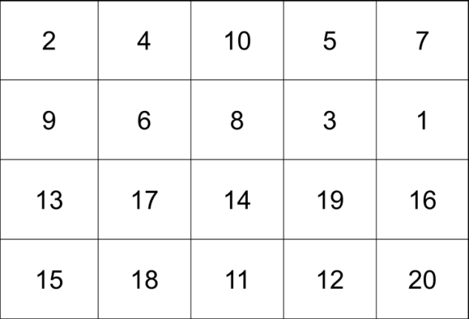

1. **One-to-one correspondence**

|  |  |  |  |
| --- | --- | --- | --- |
| Child identifies 3 items | 1 | 0 | 999 |
| Child identifies 8 items | 1 | 0 | 999 |
| Child identifies 15 items | 1 | 0 | 999 |
| **Persistence / Engagement** | | | |
| Child stays concentrated on the task at hand; is not easily distracted | 1 | 0 | 999 |
| Child is motivated to complete task; does not want to stop the task. | 1 | 0 | 999 |

1. **Addition/Subtraction**

|  |  |  |  |
| --- | --- | --- | --- |
| Child adds 3 and 2 | 1 | 0 | 999 |
| Child adds 2 and 2 | 1 | 0 | 999 |
| Child subtracts 1 from 3 | 1 | 0 | 999 |

1. **Puzzle completion**

|  |  |  |  |
| --- | --- | --- | --- |
| Number of puzzle pieces fit together (0, 2, 3, 4, 5) |  | | 999 |
| **Persistence / Engagement** | | | |
| Child stays concentrated on the task at hand; is not easily distracted | 1 | 0 | 999 |
| Child is motivated to complete task; does not want to stop the task. | 1 | 0 | 999 |

1. **Friends**

|  |  |  |
| --- | --- | --- |
| Number of friends named (0-10) |  | 999 |

1. **Emotional regulation**

|  |  |  |  |
| --- | --- | --- | --- |
| Child identifies something that makes them sad | 1 | 0 | 999 |
| Child identifies one way to deal with sad feeling | 1 | 0 | 999 |
| Child identifies another way to deal with sad feeling | 1 | 0 | 999 |
| Child identifies something that makes them happy | 1 | 0 | 999 |

1. **Empathy**

|  |  |  |  |
| --- | --- | --- | --- |
| Child identifies that friend is feeling sad/hurt/upset | 1 | 0 | 999 |
| Child gives one response for how to make friend feel better | 1 | 0 | 999 |
| Child gives second response for how to make friend feel better | 1 | 0 | 999 |

1. **Solving conflict**

|  |  |  |  |
| --- | --- | --- | --- |
| Child gives one response for how to solve conflict | 1 | 0 | 999 |
| Child gives second response for how to solve conflict | 1 | 0 | 999 |
| Child gives third response for how to solve conflict | 1 | 0 | 999 |

1. **Working memory**

|  |  |  |  |
| --- | --- | --- | --- |
| 1…6 | 1 | 0 | 999 |
| 5…2…9 | 1 | 0 | 999 |
| 8…3…1…4 | 1 | 0 | 999 |
| 1…2…4…7…3 | 1 | 0 | 999 |

1. **Head-Toes Game**

|  |  |  |  |  |  |  |
| --- | --- | --- | --- | --- | --- | --- |
| Child understands directions (Move on to next item if child DOES NOT understand) | | | | | 1 | 0 |
| Touch your head | 2 (Touches toes immediately) | 1 (Self-corrects to toes) | | 0 (Does not touch toes) | | |
| Touch your toes | 2 (Touches head immediately) | 1 (Self-corrects to head) | | 0 (Does not touch head) | | |
| Touch your toes | 2 (Touches head immediately) | 1 (Self-corrects to head) | | 0 (Does not touch head) | | |
| Touch your head | 2 (Touches toes immediately) | 1 (Self-corrects to toes) | | 0 (Does not touch toes) | | |
| Touch your toes | 2 (Touches head immediately) | 1 (Self-corrects to head) | | 0 (Does not touch head) | | |
| **Persistence / Engagement** | | | | | | |
| Child stays concentrated on the task at hand; is not easily distracted | | | 1 | | 0 | 999 |
| Child is motivated to complete task; does not want to stop the task. | | | 1 | | 0 | 999 |

1. **Expressive vocabulary**

|  |  |  |
| --- | --- | --- |
| Number of market items named (0-10) |  | 999 |
| Number of animals named (0-10) |  | 999 |

1. **Print awareness**

|  |  |  |  |
| --- | --- | --- | --- |
| Child opens the book appropriately (turns book so words are no longer upside down) | 1 | 0 | 999 |
| Child points to text on the page (can be the full sentence, the first word, or whole text) | 1 | 0 | 999 |
| Child shows direction of text | 1 | 0 | 999 |

1. **Letter ID**

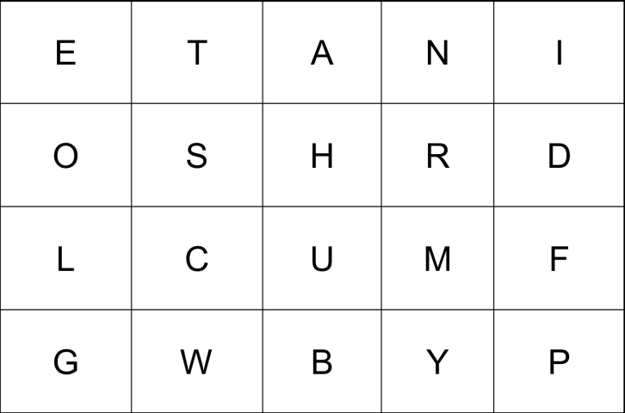

1. **First letter sounds**

|  |  |  |  |
| --- | --- | --- | --- |
| Child identifies /s/ word pair | 1 | 0 | 999 |
| Child identifies /t/ word pair | 1 | 0 | 999 |
| Child identifies /d/ word pair | 1 | 0 | 999 |

1. **Writing**

|  |  |  |
| --- | --- | --- |
| Writing level (0-4) |  | 999 |

1. **Listening comprehension**

|  |  |  |  |
| --- | --- | --- | --- |
| “Who stole the cat’s hat?” (the mouse) | 1 | 0 | 999 |
| “Can you tell me the color of the hat?” (red) | 1 | 0 | 999 |
| "Why was the cat chasing the mouse?” (because the mouse took/stole its hat) | 1 | 0 | 999 |
| ”Where did the cat trap the mouse?” (under the table) | 1 | 0 | 999 |
| ”Why did the cat not eat the mouse?” (because the mouse gave back the hat) | 1 | 0 | 999 |
| **Persistence /Engagement** | | |  |
| Child stays concentrated on the task at hand; is not easily distracted | 1 | 0 | 999 |
| Child is motivated to complete task; does not want to stop the task. | 1 | 0 | 999 |

1. **Copying a shape**

|  |  |  |  |
| --- | --- | --- | --- |
| Number of closed corners, no gaps (0, 1,2, 3) |  | | |
| Resembles closely the picture (diagonal, relatively straight lines) | 1 | 0 | 999 |

1. **Drawing a person**

|  |  |  |  |
| --- | --- | --- | --- |
| Child draws a head | 1 | 0 | 999 |
| Child draws a trunk/body | 1 | 0 | 999 |
| Child draws arms | 1 | 0 | 999 |
| Child draws legs | 1 | 0 | 999 |
| Child draws 1 facial feature | 1 | 0 | 999 |
| Child draws 2 facial feature | 1 | 0 | 999 |
| Child draws hands | 1 | 0 | 999 |
| Child draws feet | 1 | 0 | 999 |
| **Persistence / Engagement** | | | |
| Child stays concentrated on the task at hand; is not easily distracted | 1 | 0 | 999 |
| Child is motivated to complete task; does not want to stop the task. | 1 | 0 | 999 |

1. **Folding**

|  |  |  |  |
| --- | --- | --- | --- |
| Number of steps followed correctly (0-4) |  | | 999 |
| **Persistence / Engagement** | | | |
| Child stays concentrated on the task at hand; is not easily distracted | 1 | 0 | 999 |
| Child is motivated to complete task; does not want to stop the task. | 1 | 0 | 999 |

1. **Hopping**

|  |  |  |
| --- | --- | --- |
| Number of steps hopped (0-10) |  | 999 |

**Observation**

|  |  |  |  |  |
| --- | --- | --- | --- | --- |
|  | Almost never | Sometimes | Often | Almost always |
| Did the child pay attention to the instructions and demonstrations throughout the assessment? | 1 | 2 | 3 | 4 |
| Did child show confidence when completing activities; did not show hesitation. | 1 | 2 | 3 | 4 |
| Did the child stay concentrated and on task during the activities and was not easily distracted? | 1 | 2 | 3 | 4 |
| Was child careful and diligent on tasks? Was child interested in accuracy? | 1 | 2 | 3 | 4 |
| Did child show pleasure in accomplishing specific tasks? | 1 | 2 | 3 | 4 |
| Was child motivated to complete tasks? Did not give up quickly and did not want to stop the task? | 1 | 2 | 3 | 4 |
| Was the child interested and curious about the tasks throughout the assessment? | 1 | 2 | 3 | 4 |